Gigli wire Dehorning

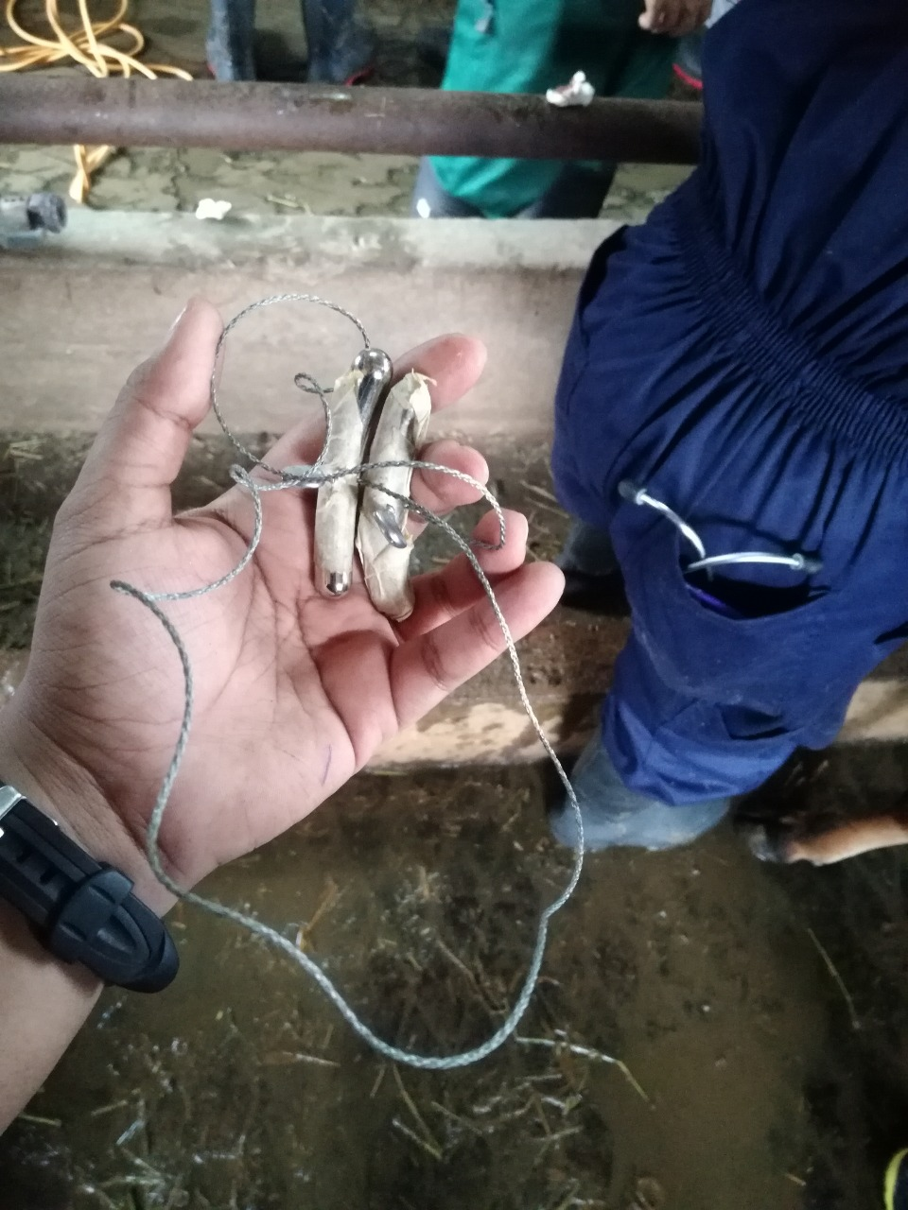

Technique:

1. Restrain and administer sedation, analgesia and local anaesthetic
2. Clip the area around both horns
3. The head of the animal is positioned ventrally facing the ground
4. A scalpel is used to incise the skin in a ring 1 cm from the base of the horn to be cut and so ensure the Gigli wire is properly secured around the horn preventing slippage during sawing

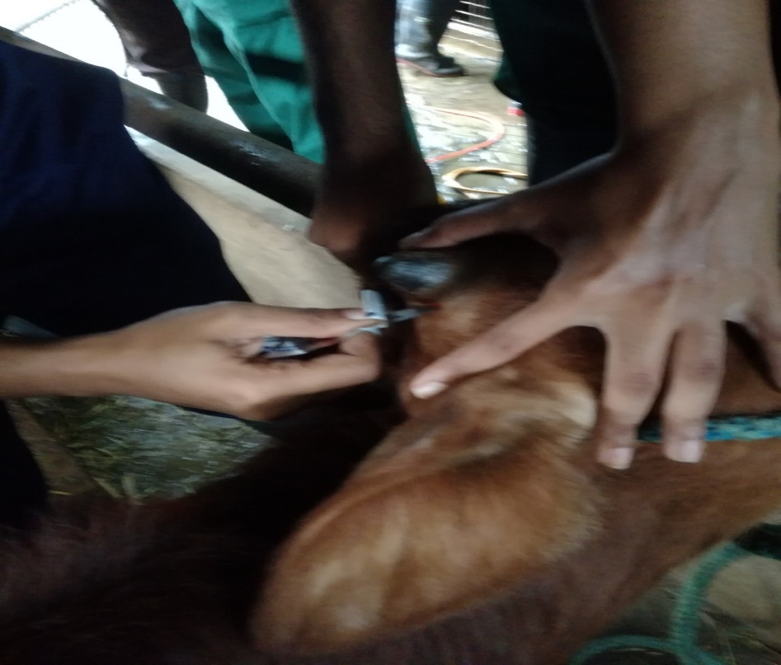

1. The Gigli wire is then placed around the horn within the marked region

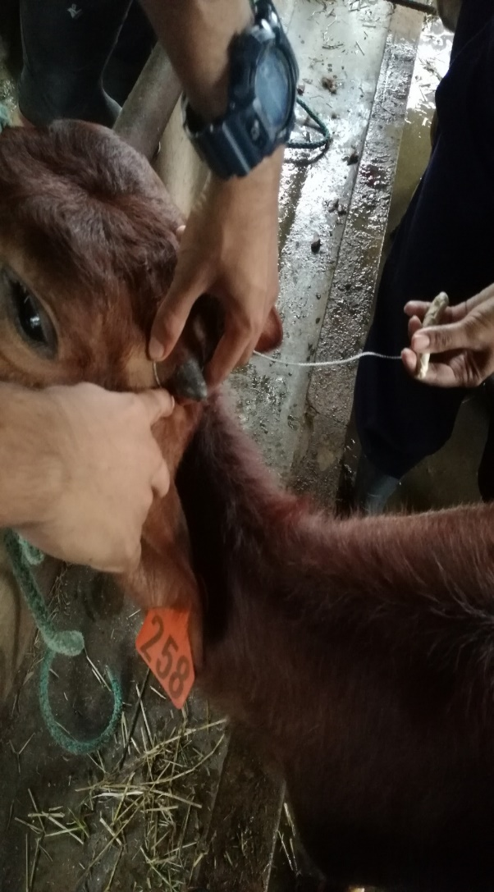 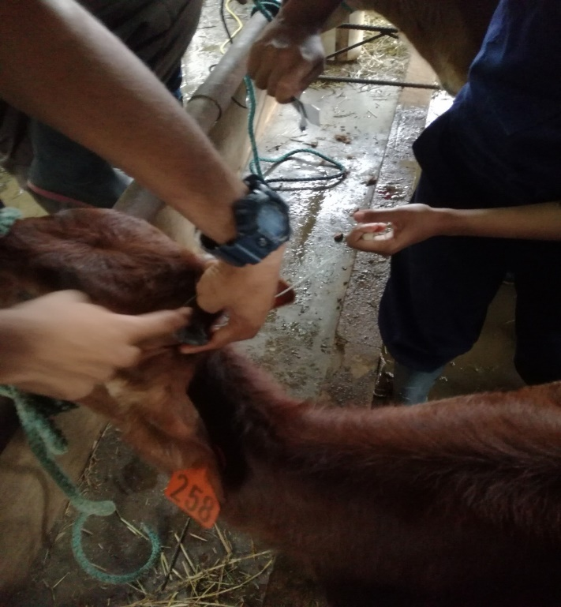

1. And the wire is moved smoothly and quickly back and forth in a sawing motion consistently from the back of the horn, forward making sure that the pulling movement was made while holding ventrally towards the ground until the horn and surrounding tissue is removed.
2. Bleeding cornual artery is clamped by a haemostat or cauterized by a hot iron

