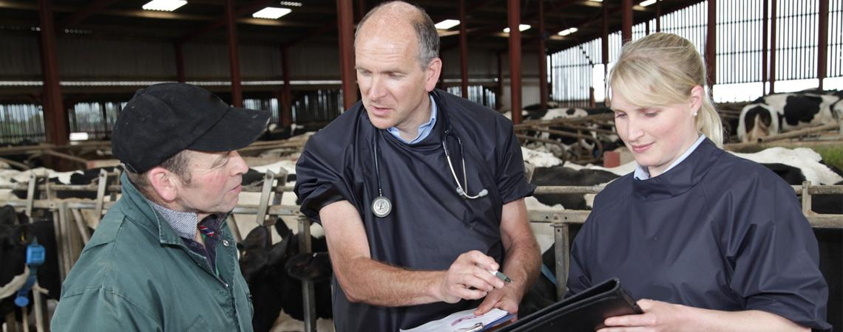

**The Importance of Client Communication**

Having a good relationship with clients is very important. It causes:

* Clients to trust the veterinarian more by allowing the veterinarian to show their knowledge to the client on the relevant information
* Educate the client so he makes better choices
* Enhance productivity
* Increase safety
* Animal welfare is increased
* Increase economic profits
* Protection of the veterinarian legally

With respect to dehorning, client communication is very important. The client must be allowed to know:

* Drugs used (especially if any are to be used extra label)
* Restraint needed
* Complications of procedure
* Follow up treatments involved
* Pain involved
* The steps of the procedure
* Why the procedure should be done (advantages)
* Cost involved (equipment, labour, follow- up treatment etc.)
* When the process should be done