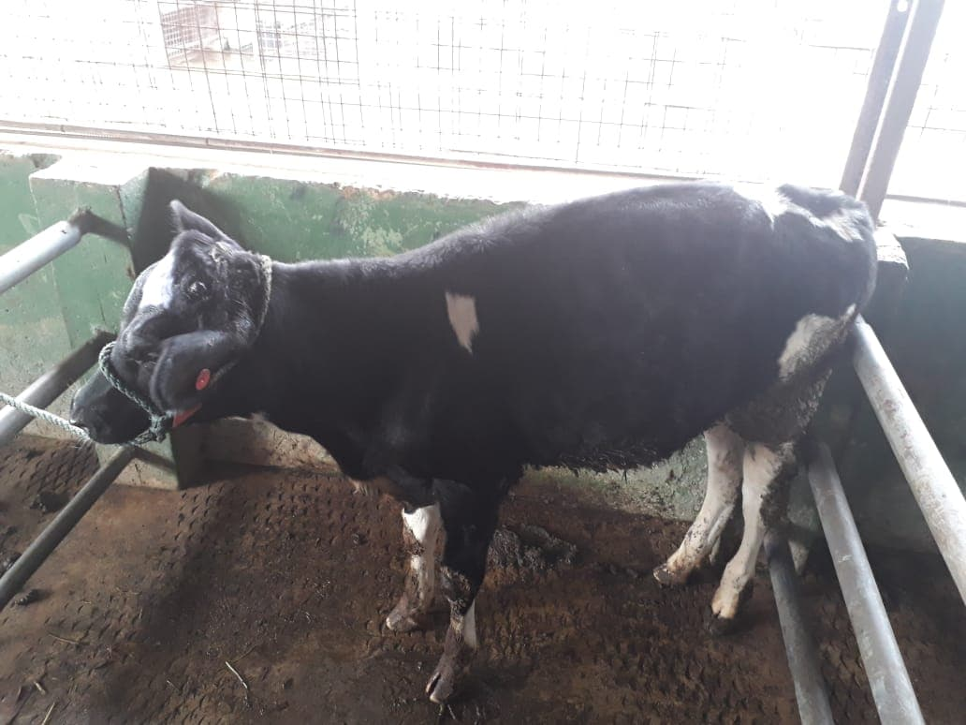**Signalment:** 3-month Jersey bull

**Physical Exam:** BAR, all parameters where within normal limits, BCS 3/5 using Penn State with an ASA grade of 1

**Weight:** 150kg

**Equipment:**

* Physical Restraint: Halter with quick release slip knot, nose pinch
* Physical Exam: Stethoscope, thermometer, weight tape
* Pain & Anti- Inflammatory Drugs: Banamine, 3ml syringe, 20g needles

Banamine: $\frac{1.1 \frac{mg}{kg}×150kg}{50\frac{mg}{ml}}$ = 3.3mls

* Antibiotics: Combikel, 5ml syringe, 20g needles

Combikel: $\frac{10,000\frac{IU}{kg}×150kg}{200,000\frac{IU}{ml}}$ = 7.5mls

* Procedure: 10ml syringes, Lidocaine, 20g needles, scalpel blade, hemostats, hot iron dehorner, cotton swabs, hair clippers, alcohol, screw worm spray, Tetravet topical antibiotics

Lidocaine: $\frac{10\frac{mg}{kg}×150kg}{20\frac{mg}{ml}}$ = 75mls

½ toxic Dose: 37.5mls

**Anatomy:**

Site of Local anesthesia: Cornual branch of the Lacrimal Nerve located midway between the lateral canthus of the eye and the base of horn under the frontal ridge.

Test to ensure that the block worked by sticking a needle in the area until blood oozed and no response from the animal.

[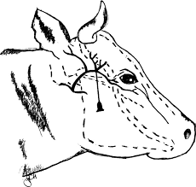](https://www.google.com/url?sa=i&rct=j&q=&esrc=s&source=images&cd=&cad=rja&uact=8&ved=2ahUKEwju0fSetN_dAhUwzlkKHYTkBecQjRx6BAgBEAQ&url=http://cmapsconverted.ihmc.us/rid%3D1RR753V2T-13PVTML-KG/Local-and-Regional-Anesthesia-in-Cattle-VET-CLINICS-NA.pdf&psig=AOvVaw3A2vt7OmLL_tg6GQjQLgFB&ust=1538282576213124)