**What is dehorning?**

Firstly, horns are the pairs of hard, bonelike, permanent growths projecting from the heads of cattle. They grow from a unique area of skin cells at the base of the horn. At about two months of age, horns become attached to the frontal bone of the skull. A sinus lies within the skull beneath the horn bud. As the horn grows and attaches to the skull, this frontal sinus joins into the adjacent portion of the horn.

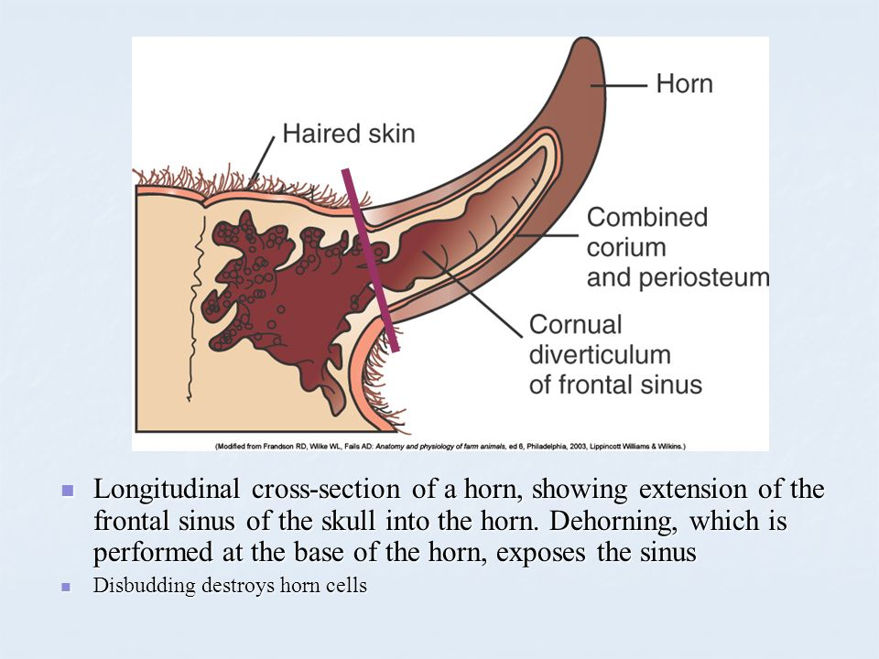

Horned cattle have horns because they have not been dehorned or they are not polled. Some breeds are naturally (genetically) hornless. Dehorning involves cutting out both horns **AND** horn- producing tissue after they have formed from the horn bud and attached to the skull. This is to prevent re- growth of the horns.

There are two methods:

1. Chemical Method
2. Mechanical Method

**Chemical Method:**

Caustic chemicals will prevent the growth of horns when properly applied to the horn buds of new-born (less than one to three weeks of age) calves. The chemical destroys the horn-producing cells around the horn bud. The chemicals are available as sticks or pastes. To protect yourself, wear gloves when applying the chemicals. To protect the calf, avoid application near its eyes. Do not use caustics in rainy weather.

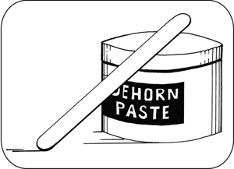

**Technique**

1. Administer sedation, analgesia and local anaesthetic.
2. Expose the horn bud (about the size of a 5-cent piece) by trimming the hair.
3. Apply petroleum jelly to prevent burning the skin.
4. Apply the caustic to the horn button. Use a wooden applicator. Apply a thin layer.
5. Re-position the hair over the paste and horn bud - i.e., cover the horn bud.
6. Although the package insert may instruct operators to clip hair at the horn bud, experienced operators have shown that not clipping hair is preferable, because the hair keeps the caustic in place, reduces the risk of irritation to the cow’s udder and flanks and reduces irritation to other facial skin of the calf.
7. Protect the calf and the cow from accidental caustic burns. One method is to place a patch of duct tape over each horn bud. The duct tape usually falls off in a few days. For dairy calves, keep in individual pens.
8. In some countries, the technique is only permitted in calves less than eight days of age.

**Mechanical Method:**

The mechanical method is using other means of dehorning using various forms of equipment to get the job done. Examples of equipment are:

* Hot iron

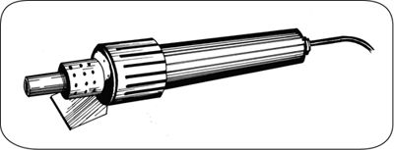

* Dehorning spoon

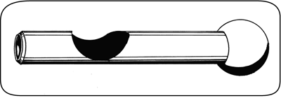

* Barnes dehorner

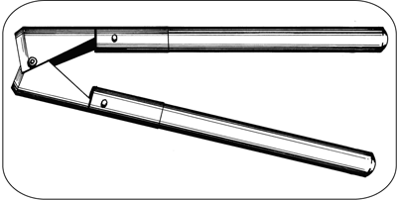

* Gigli Wire with Handles

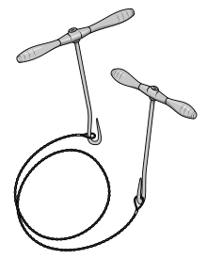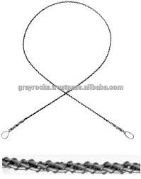

* Keystone Dehorner

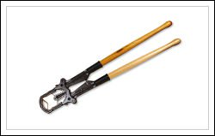

* Dehorning is a recommended procedure as it has many advantages and benefits, however, the procedure, itself should be explained properly and in a detailed manner. It is a very painful and sometimes bloody procedure and farmers who are very attached to their animals may seem uncomfortable if seeing for the first time. This should be told to the farmer prior for it to expected and explained that it is a normal event during the process and not to be alarmed. There are various ways that blood loss can be prevented such as: using a haemostat by clamping when the vessel is isolated, clotting the blood with dressing powder, or cauterizing the artery with heat.

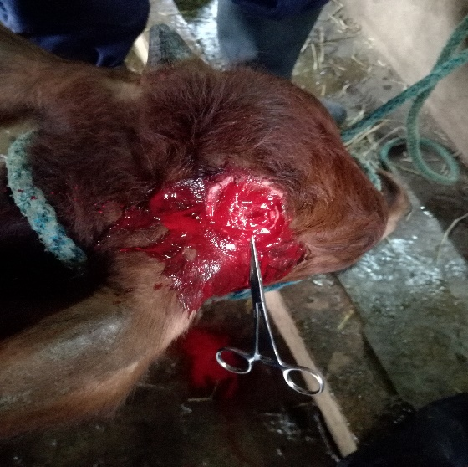

**Figure 1: Haemostat placed on the cornual artery to prevent further blood loss**

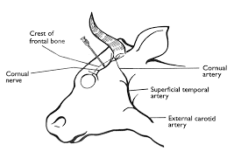

**Figure 2: Cornual artery location**

* Sedation is necessary even in initially docile animals as the animals can get fractious during the process. 2% Xylazine and 10% Lidocaine are commonly used to accomplish this. The farmer should be made aware of this and told that time for the effect will be waited upon. Also, signs of urination and excess salivation should be noted.
* Dehorning should always be done with a local anaesthetic and analgesic and tested before the procedure is conducted. Antibiotic should also be administered to help prevent infection. Explaining this to the farmer can prevent or reduce any reservations the farmer might have. Also, it displays that the veterinarian is aware and concerned for the welfare of the animal is conducting with good practise and medicine. There is increasing interest in the use of anaesthetic or analgesic drugs to reduce the pain associated with dehorning. An *anaesthetic* (e.g. lidocaine) is a drug that temporarily eliminates **all** feeling. Local anaesthetics cause numbness; general anaesthetic cause unconsciousness. Anaesthetics need to be injected 5 to 20 minutes before the operation and can provide several hours of pain relief. An *analgesic* temporarily eliminates pain, but not normal sensation. Injectable analgesics such as ketoprofen (Anafen), flunixin meglumine (Banamine) and meloxicam (Metacam) are longer-acting than anaesthetics and may provide some pain relief for up to one day after dehorning by reducing swelling and pain.