**Dehorning**

**Post-procedure**

**Ketamine stun (xylazine/ketamine)**

The ketamine stun utilized for sedation of the calf induces its effects after about 2 minutes, reaching maximum effect after around 5 minutes post administration.

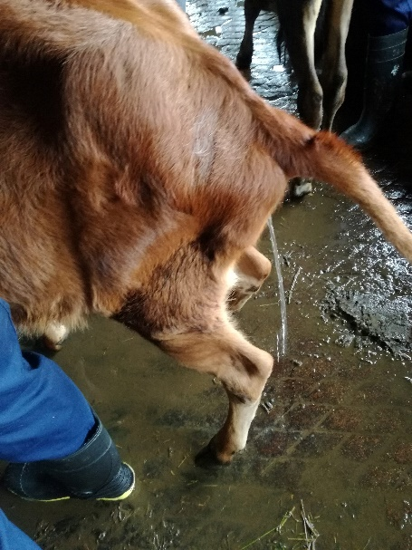

Signs observed upon onset include:

* Increased salivation
* Voiding of urine and faeces

(Our calf began urinating 11mins after the block was given)

* Lowering of the head
* Decrease in alertness

**Cornual block of the lacrimal nerve**

The 2% lidocaine administered in the block of the corneal branch of the lacrimal nerve typically initiates its effects within 2-5 minutes. Its anaesthetic effects last approximately 1- 1½ hours, providing sufficient time to conduct the dehorning procedure with greater ease.

The block is confirmed by the needle prick test, where a needle is used to repeatedly pierce the skin of the corium surrounding the base of the horn. Absence of a reaction when this is done confirms complete desensitization of the area, ensuring the block has taken full effect.

**Post-dehorning**

After the horn is removed, any bleeding must be controlled. This is done by the application of a haemostat or cauterization at the cut end of the vessel to prevent excess blood loss. The area is inspected to ensure the horn was cut as precisely as possible to ensure the prevention of horn regrowth. Also, the area is also examined to see if the frontal sinus was breached and exposed. Any opening into the frontal sinus can lead to severe consequences if not treated properly e.g. sinusitis.