Paravertebral Nerve Blocks

What is it?

Paravertebral anesthesia refers to the perineural injection of local anesthesia about the spinal nerves as they emerge from the vertebral canal through the intervertebral foraminae.

Proximal Paravertebral block:

Purpose:

Indicated for standing laparotomy surgery such as C-section, rumenotomy, cecostomy, correction of gastrointestinal displacement, intestinal obstruction and volvulus.

Method:

* The dorsal aspect of the transverse processes of the last thoracic (T-13) and first and second lumbar (L-1 and L-2) vertebrae is the site for needle placement.
* The dorsal and ventral roots of the last thoracic (T-13) and 1st and 2nd lumbar spinal nerves emerge from the intervertebral foramina and are desensitized.
* To desensitize T13, a cannula needle is placed through the skin at the anterior edge of the transverse process of L1 at approximately 4 to 5 cm lateral to the dorsal midline. An 18-gauge 10- to 15-cm spinal needle is passed ventrally until it contacts the transverse process of L1. The needle is then walked off the cranial edge of the transverse process of L1 and advanced approximately 1 cm to pass slightly ventral to the process and into the intertransverse ligament. A total of 6 to 8 mL of local anaesthetic is injected with little resistance to desensitize the ventral branch of T13. The needle is then withdrawn 1 to 2.5 cm above the fascia or just dorsal to the transverse process and 6 to 8 mL of local anaesthetic is infused to desensitize the dorsal branch of the nerve.
* To desensitize L1 and L2, the needle is inserted just caudal to the transverse processes of L1 and L2. The needle is walked off the caudal edges of the transverse processes of L1 and L2, at a depth like the injection site for T13, and advanced approximately 1 cm to pass slightly ventral to the process and into the intertransverse ligament. A total of 6 to 8 mL of local anaesthetic is injected with little resistance to desensitize the ventral branches of the nerves. The needle is then withdrawn 1 to 2.5 cm above the fascia or just dorsal to the transverse processes and 6 to 8 mL of local anaesthetic is infused to desensitize the dorsal branch of the nerve.

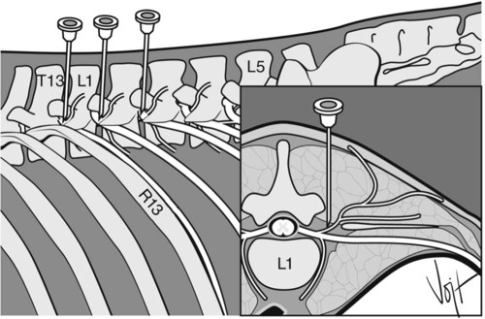*-*  *Needle placement for proximal paravertebral nerve block in cattle. Left lateral aspect and cranial view of a transection of the first thoracolumbar vertebra at the location of the intervertebral foramen. R13 is the last rib; T13, L1, and L5 are the spinous processes of the last thoracic and the first and fifth lumbar vertebrae, respectively.*

* 10-20 ml of 2% lidocaine is injected to each site onset occurs usually within 10 minutes of injection.
* Analgesia of the skin causes scoliosis toward the desensitized side - due to paralysis of the paralysis of the paravertebral muscles, increased skin temperature due to vasodilation (paralysis of cutaneous vasomotor nerves) indicates effective block. Duration of analgesia lasts approximately 90 minutes

Distal Paravertebral block:

* The dorsal and ventral rami of the spinal nerves T13, L1 and L2 are desensitized at the distal ends of L-1, L-2 and L-4.
* A 7.5-cm, 18-gauge needle is inserted ventral to the tips of the respective transverse processes in cows where approximately 10-20 ml of a 2% lidocaine solution are injected in a fan-shaped infiltration pattern.
* The needle is completely withdrawn and reinserted dorsal to the transverse process, where the cutaneous branch of the dorsal rami is injected with about 5 ml of the analgesic.
* The procedure is repeated for the second and fourth lumbar transverse processes.
* 10-20 ml 2% lidocaine is used per site and onset and duration like proximal technique.

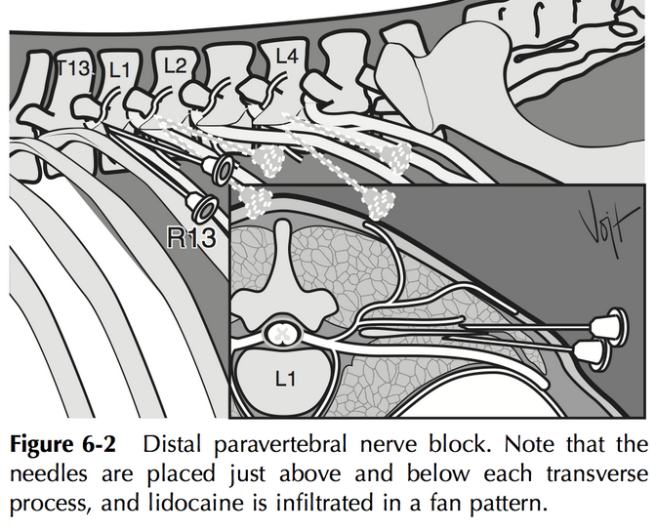

Table showing the advantages and disadvantages of a Proximal paravertebral block and a Distal paravertebral block.

|  |  |  |
| --- | --- | --- |
| Techniques | Advantages | Disadvantages |
| Proximal paravertebral block | 1. Small dose of analgesic  2. Wide and uniform area of analgesia and muscle relaxation.  3. Minimal intra-abdominal pressure.  4. Increased intestinal tone and motility  5. Absence of local analgesic from the operative wound margins | 1. Technical difficulty  2. Arching up of the spine due to paralysis of the back muscles.  3. Risk of penetrating vital structures such as the aorta and thoracic longitudinal vein on the left side and the caudal vena cava on the right side. |
| Distal paravertebral block | 1. The use of more routine size needles, no risk of penetrating a major blood vessel.  2. Lack of scoliosis minimal weakness in the pelvic limb and ataxia. | 1. Larger doses of anaesthetic are needed.  2. Variation in efficiency exists, particularly if the nerves vary in their anatomical pathway. |