Caudal epidural anaesthesia

What is it?

* Caudal epidural anaesthesia is an anaesthetic procedure where a local anaesthetic is injected into the first coccygeal intervertebral space which is created between the 1st and 2nd coccygeal vertebrae (low caudal epidural)

Nerves desensitized:

* Low caudal epidural – sacral nerves; 3,4 and 5.

Areas desensitized: tail, anus, vulva, perineum, caudal udder, scrotum and upper hindlimbs.

Purpose: used for obstetric manipulations and control pain for surgical procedures involving the tail, perineum, anus, rectum, vulva, vagina, prepuce, and scrotum.

Method:

1. Hair should be clipped, and the skin scrubbed and disinfected.
2. Standing alongside the cow, the tail should be moved up and down to locate the fossa between the first and second coccygeal vertebrae.
3. An 18-gauge 3.8-cm needle (with no syringe attached) is directed perpendicular to the skin surface.
4. Once the skin is penetrated, placement of the needle into the epidural space beyond penetration of the ligamentum flavum can be validated by one of the two techniques.
5. Negative pressure would allow the anaesthetic solution to be drawn within the epidural space with lack off resistance when administered.

There are two techniques through which this procedure can be carried out:

* The “hanging drop” technique - involves removing the stylet of the spinal needle, filling the hub of the needle with saline or anaesthetic solution, and allowing one drop to hang from the hub. As the needle is advanced through the ligamentous structures, the drop does not move. However, upon penetration of the ligamentum flavum, the negative pressure in the epidural space will draw the drop of solution into the needle, indicating proper placement in the epidural space. A “pop” felt through the needle is usually encountered when the spinal needle is passed through the ligamentum flavum.
* The “lack of resistance” technique indicates proper placement of the injection needle in the epidural space based on the amount of resistance to the injection of air or saline. Once in the epidural space, the injection of air, saline, or anaesthetic solution will encounter minimal resistance. (In case of lab, 1ml of air space was left in the syringe along with the 10ml of 2% Lidocaine, when needle entered the ligamentum flavum and anaesthetic solution was injected into the epidural space no resistance was observed)

Risks associated:

* Infection- Careful sterile precautions (good clipping and scrubbing)
* Irritation causing spinal damage (most likely with subarachnoid).
* Hindlimb motor paralysis (problem in large animals, acceptable in small).
* Hypotension - most likely with an anterior block. Where this is being done fluid therapy or inotropes should be available to maintain blood pressure.
* Respiratory paralysis (only if massive overdose of local analgesic used).

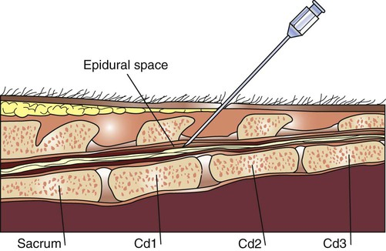

*figure 1, showing penetration of a needle into the epidural space (between the 1st and 2nd coccygeal vertebrae )*

*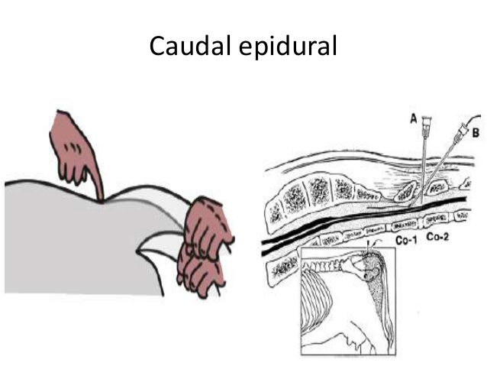*

*Figure 2, represents the first obvious articulation that occurs after the sacrum; area to conduct the epidural block.*