**Pre -Operative procedure**

**Signalment :**

* I.D#: 126 Sex: Female Breed: Holstein
* Age: 2-2 ½ years BCS: 3.0/3.5 (Penn State scale)
* Weight: 450kg
* Mentation: BAR
* Temperature: 39°C
* Pulse Rate: 44bpm
* Resp. Rate: 40 breaths/min
* PE: A healing wound on her left flank

**Equipment used:**

**For restraint:**

1. **Halter:**

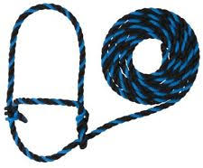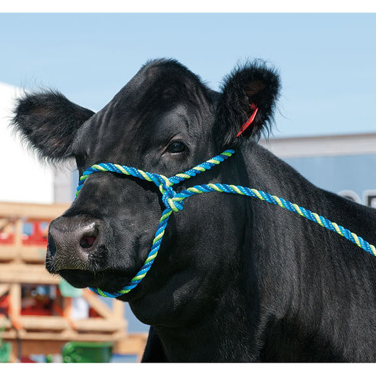

1. **Stanchion:**

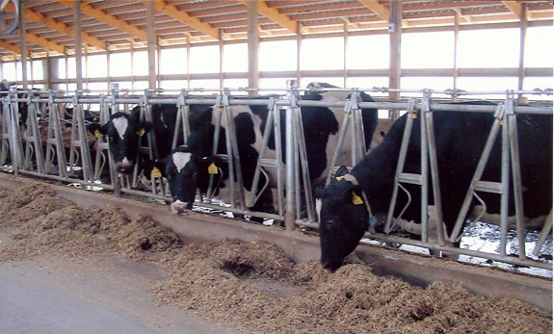

1. **Nose clamp:**

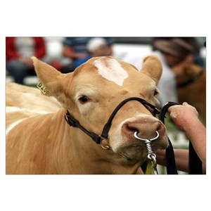

1. **Chemical Restraint**:

* **0.05 mg/kg 10% Ketamine**
* ***Ketamine is considered to have a wide therapeutic index (approximately 5 times***

***greater when compared to pentobarbital). When given in excessive doses or too rapidly,***

***significant respiratory depression may occur. Treatment using mechanically assisted respiratory support is recommended versus the use of analeptic agents.***

* ***Adverse reactions include respiratory depression following high doses, emesis, vocalization, erratic and prolonged recovery, dyspnoea, spastic jerking movements, convulsions, muscular tremors, hypertonicity, opisthotonos and cardiac arrest.***

Calculation:

$$Volume= \frac{Dose ×Weight}{Concentration }$$

*Weight: 450kg

* Dose: 0.05mg/kg

* Concentration: 10% = 100

$\frac{0.05 ×450}{100}=0.3mls$

* **0.025mg/kg 2% Xylazine (low dose)**
* ***Adverse effects cattle: salivation, ruminal atony, bloating, regurgitation,***

***hypothermia, diarrhoea, bradycardia, premature parturition and ataxia.***

***. Yohimbine, Atipamezole and tolazoline may be used alone or in combination to***

***reverse effects or speed recovery times***

* ***Ruminants generally require approximately 1/10th the dosage that is required for horses to exhibit the same effect. In cattle (and occasionally cats and horses), polyuria is seen following xylazine administration, probably because of a decreased production of vasopressin (anti-diuretic hormone, ADH). Bradycardia and hypersalivation are also seen in cattle and are diminished by pre-treating with atropine.***

Calculation:

$$Volume= \frac{Dose ×Weight}{Concentration }$$

*Weight: 450kg

*Dose: 0.025mg/kg

*Concentration: 2%= 20

$$\frac{0.025 ×450}{20 }=0.6 mls$$

**Emergency Drugs:**

* **Atropine** (Conc.: 0.54 mg/ml, Dose: 0.04mg/kg)

Volume Calculation: $$\frac{0.04 ×450}{0.54 }=33.33mls$$

* **Epinephrine** (Conc.: 1mg/mL, Dose: 0.02mg/kg)

Volume Calculation: $$\frac{ 0.02×450}{1 }=9mls$$

* **10% Tolazoline** (To reverse Xylazine)

Volume Calculation:

*V1: 0.6mls

*C1: 2%

*C2: 10%

**If Xylazine Toxicity is:**

**Mild**: 0.12 × 2= 0.24mls

**Severe**: 0.12× 4= 0.48mls

**Anaesthetic Drug used**:

* **2% Lidocaine**
* ***The most common adverse effects reported are dose related (serum level) and mild. CNS signs include drowsiness, depression, ataxia, muscle tremors, etc. Nausea and vomiting may occur but are usually transient. Adverse cardiac effects generally only occur at high plasma concentrations are usually associated with PR and QRS interval prolongation and QT interval shortening. Lidocaine may increase ventricular rates if used in patients with atrial fibrillation. If an IV bolus is given too rapidly, hypotension may occur.***

**Instruments:**

* 6, 1 ½” 18-gauge needles
* 6, 10mls syringes