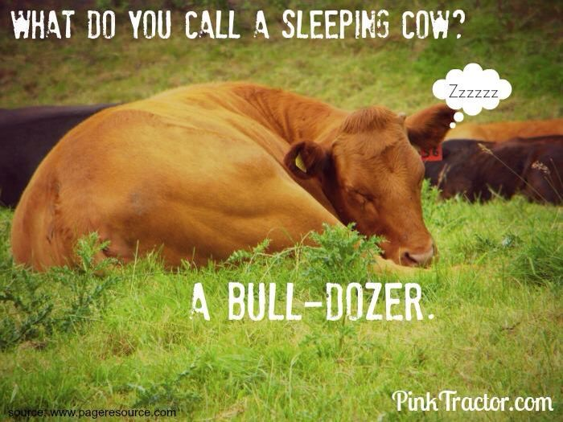

* Onset of action for Xylazine occurs 10-15 minutes post injection (IM) and duration of analgesia is approximately 15-30 minutes.
* Onset of action for Ketamine occurs 3-4 minutes post injection and duration of analgesia is approximately 12-25 minutes.
* Observation of Adverse Effects of:
  + *Xylazine* 
    - In Cattle, adverse effects may include profuse salivation, ruminal atony, bloat, regurgitation, hypothermia, diarrhoea, bradycardia, polyuria, premature parturition. Acute toxicity may cause cardiac arrhythmias, hypotension, profound CNS depression, profound respiratory depression, seizures.
  + *Ketamine*
    - In Cattle, adverse effects may include pain at the injection site. Hypersalivation and other autonomic signs. Hypotension. Increased cardiac output. Tachycardia. Mild respiratory depression: increased tidal rate does not compensate for the decreased tidal volume. Rise in arterial blood pressure (hypertension).
* The mixture of the two drugs achieves a state of sedation and a stunned/ euphoric effect when combined properly at low doses.
* Farmer Information
  + In the case of bloat maintain the Cow in sternal recumbency to avoid tympany. Placing a stomach tube can allow for any fluid to run through and prevent aspiration pneumonia. If animal is required for recumbency, sternal recumbency is advised, however, monitoring is required so the animal does not change positioning. Otherwise, left lateral is then recommended to ensure that the cardia is placed in an upward position to also reduce risks of aspiration pneumonia.

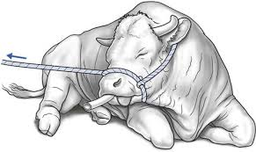

Access to water ad libitum to assist with diarrhoea and prevent dehydration. Contact the Veterinarian who conducted the procedure if the above listed adverse effects are persistent.

* Do not give Xylazine to pregnant animals especially if they are in their last trimester as it causes uterine contractions and abortions.
* Corrective Action
  + Pre-treatment with atropine may be used to alleviate hypersalivation, autonomic signs and bradycardia. Xylazine reversal with Tolazoline at two (for mildly depressed animals)-four (severely depressed animals) times the concentration rate of Xylazine has been suggested. Mechanical respiratory support with respiratory stimulants is indicated for treatment of respiratory depression.