Sedation

Sedation in cattle (and other animals) can be useful for many reasons, such as:

* To reduce stress and anxiety
* Improve animal welfare
* Reduce risk of catecholamine-induced arrhythmias
* Reduce risk of handling difficult animals and to calm and facilitate handling of fractious animals
* (hence ensuring safety of veterinarian and workers)
* To enable a thorough clinical examination
* To perform diagnostic procedures
* To perform minor surgical procedures
* As premedication prior to general anesthesia

Sedation Procedure

1. Secure cow in stanchion (physical restraint).
2. Restrain cow using a halter (physical restraint).
3. Pull up drugs in two separate syringes (of 2% Xylazine and 10% Ketamine)
4. Swab the area intended for the injection with 70 % isopropyl alcohol
5. Method 1:
   1. Know the anatomical landmarks of neck muscle to give animal intramuscular injection as seen below:

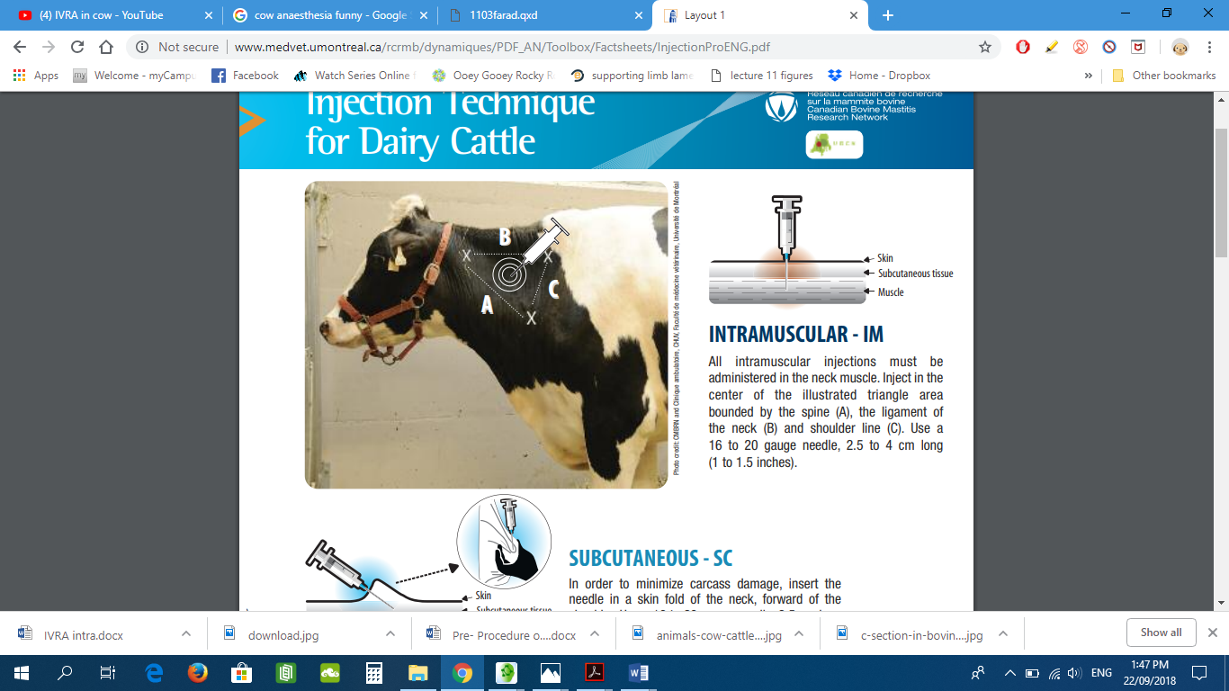

* 1. Attach the syringe.
  2. Aspirate the needle to ensure it’s not in any blood vessel.
  3. Once no blood is seen deliver the drug mixture.
  4. Remove the needle and compress the injection site to ensure none of the drugs escapes.
  5. Recap needle and dispose of it in the sharps container.

1. Observe reaction