**Intra- Procedure**

**Step 1:** Identify the anatomical site which is the base of the tail at the proximal intercoccygeal space.

This is done by moving the tail up and down while palpating the dorsal aspect of the tail to determine the intervertebral space between the sacrum and C1 and Co1 and Co2.

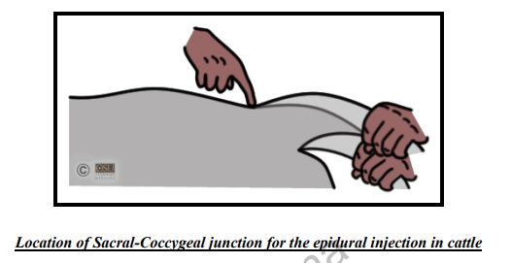

**Step 2:** 1 ½ inch 20-gauge needle was inserted into the intercoccygeal space between Co1 and Co2 from caudal to cranial at a 45֯.

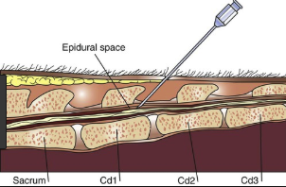

**Step 3:** Determine whether the needle is in the right area.

**Step 4:** This can be done by using two different techniques. A drop of lidocaine is placed in the hub of the needle and then advanced until a popping sensation is felt when the needle penetrates the dura matter. If it is in the right area the negative pressure will move the lidocaine into the intercoccygeal space.

OR an air space is created at the top of the syringe and then attached to the hub and advanced into the space. If moves easily into the intercoccygeal space then it is the right area. If resistance is felt then the needle needs to be redirected.

**Step 5:** After determining that the needle is in the right area the syringe is attached and 4.5mls of lidocaine is given.

**Step 6:** Wait approximately 5- 10 minutes for the lidocaine to take effect. Then test for desensitization by sticking the area with a needle and checking the tail tone. If there is no tail tone and the animal doesn’t flinch then the lidocaine worked.