 | Lidocaine 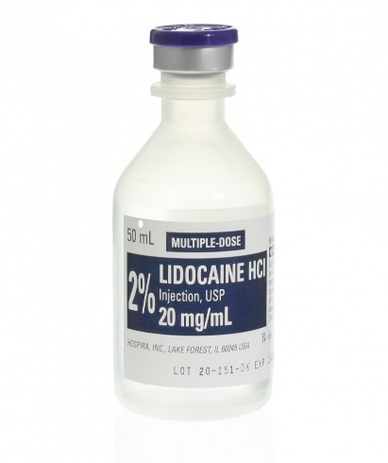 | Carbocaine 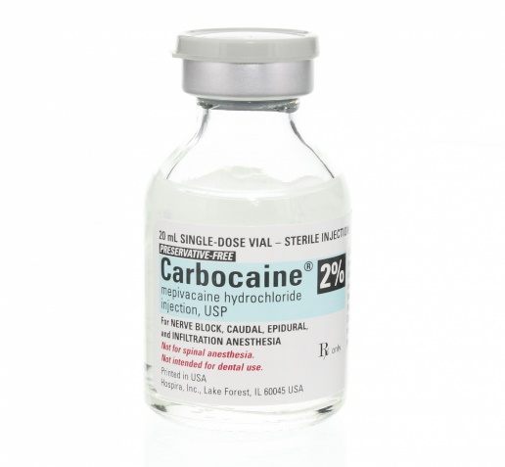 | Bupivicaine 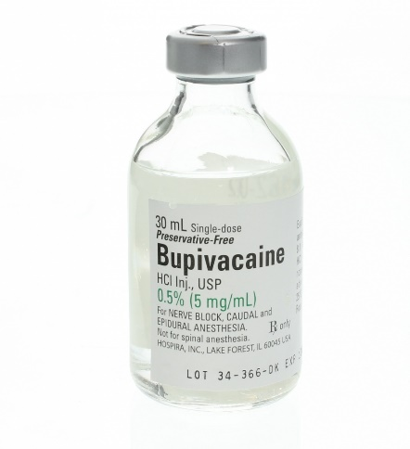
Onset of Action | <4 min | <4 min | <10 min
Duration of action | 0.5 – 1.5 h | 2 – 4 h | 6 – 10 h
Max. Recommended dose mg/kg | 5 | 5 | 2
Concentration | 2% | 2% | 0.5 to 0.75%

LOCAL ANAESTHETIC AGENTS USED IN HORSES

