**Ropivacaine**

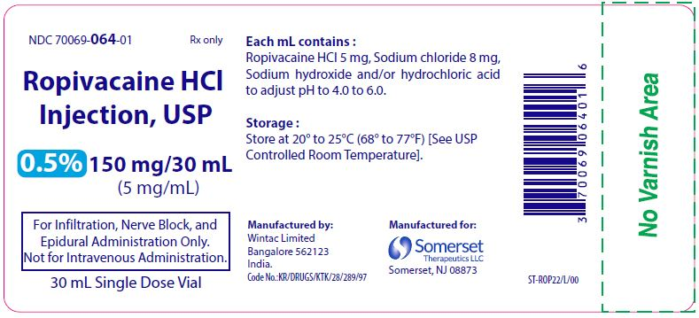

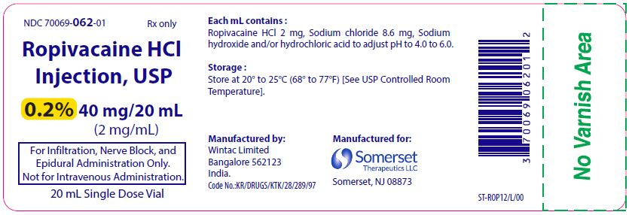

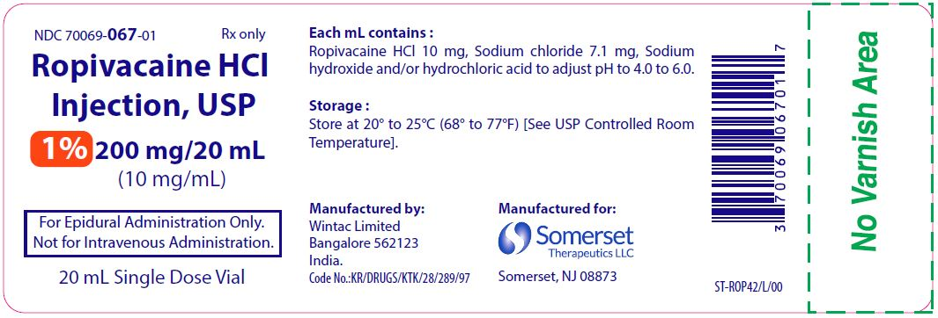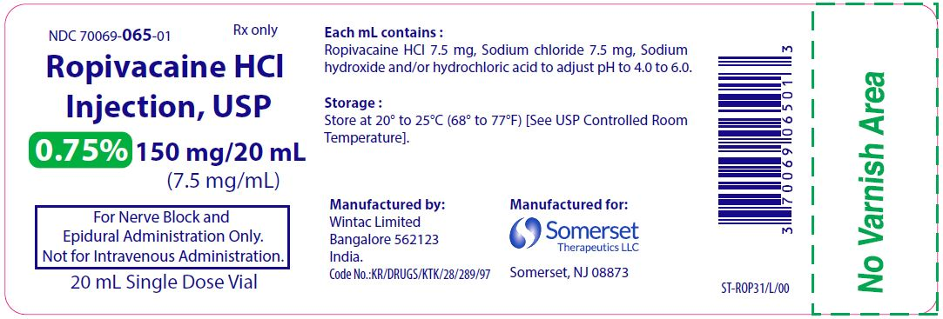

Since it is only officially approved for man and is extremely expensive for use in veterinary medicine, ropivacaine is used as an extra-label drug for local anaesthesia. It has been found to have significant positive effects, given its longer duration and its decreased risk of cardiotoxicity. It has been used for quite some time in horses with little to complication and continues to be used to conduct nerve blocks in horse limbs.