**Bupivacaine**

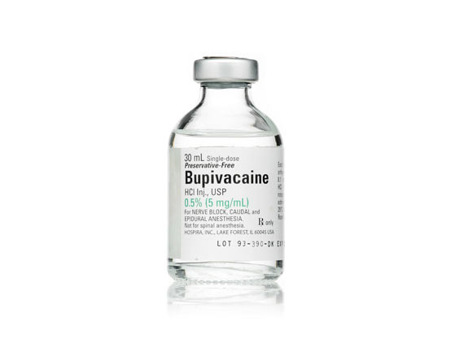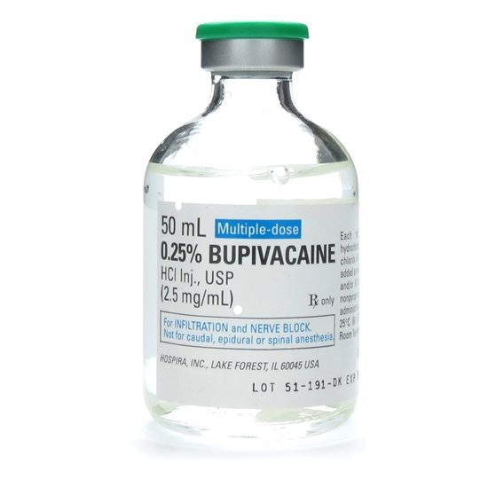

Bupivacaine is another common local anaesthetic in veterinary use. Being comparatively more potent than mepivacaine and lidocaine, it has a long duration of action, being reportedly around 4-6 hours. Furthermore, in formulations where bupivacaine is coupled with epinephrine, duration can be up to approximately 8 hours. However, the onset of the drug’s effects are slow. It is used for the diagnosis of lameness, post-op anaesthesia and lengthy invasive operations of the anaesthetized region of interest. An important consideration when using bupivacaine is that is more cardiotoxic than other drugs e.g. lidocaine. Therefore, care must be taken when determining and administering dosages.