**Lidocaine**

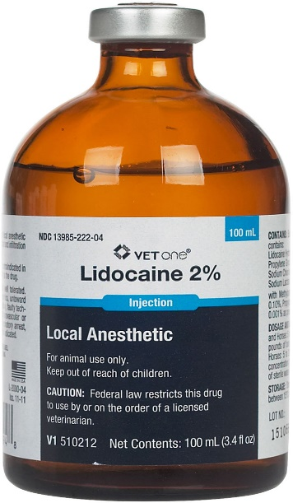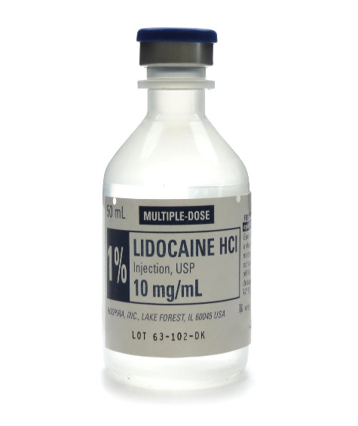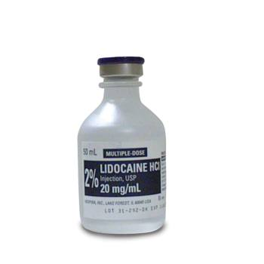

Lidocaine is one of the most widely used anaesthetic drug used in veterinary medicine. With the combination of a significant onset time (fast), duration (2-3 hours) and spreading ability, it makes it a premier candidate for general use as a local anaesthetic.

Lidocaine can be found in different metric and percentage concentrations (e.g. 0.5%, 2%, 10 mg/mL, 20 mg/mL). Furthermore, there are formulations of lidocaine that contain epinephrine. The addition of epinephrine is to facilitate longer duration times for nerve blocks since it induces vasoconstriction, leading to increased spread in the region of the block.

This is important to note as it would be wise for a physician to ensure they are utilizing the correct concentration of lidocaine, as well as the right formulation, be it with or without epinephrine.