**Ligaments:**

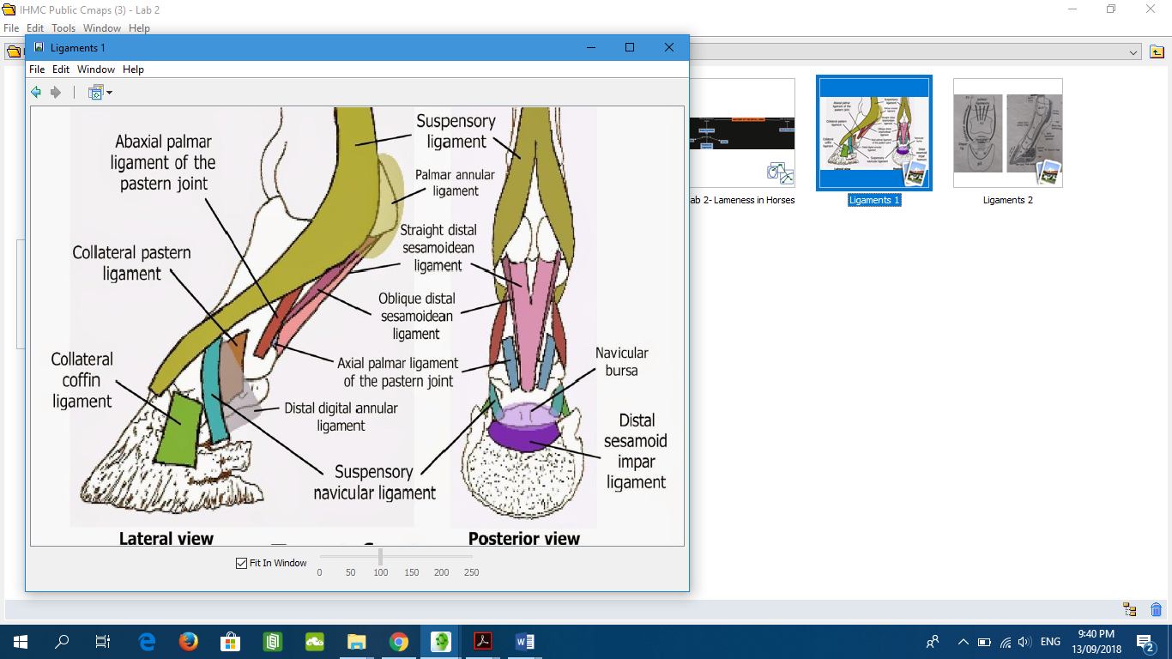

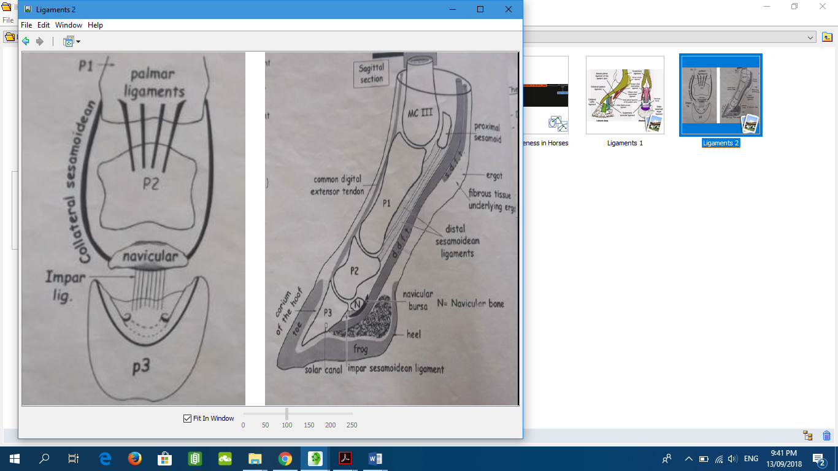 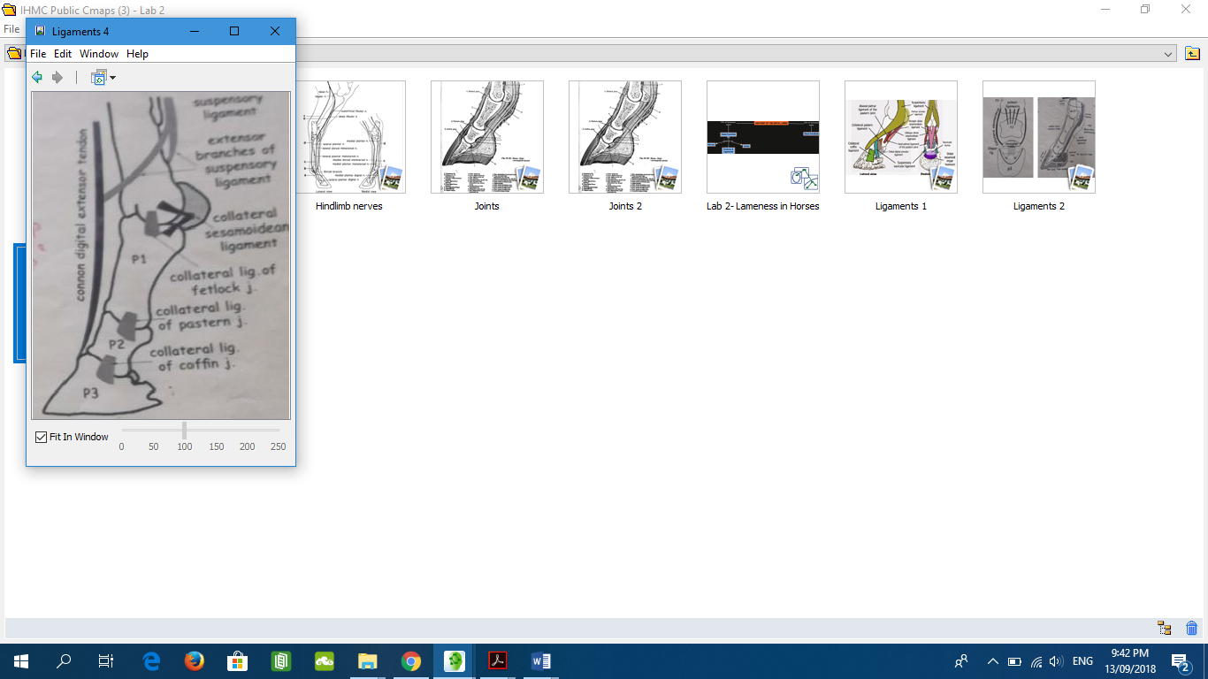

**Ligaments:**

Fetlock:

1-Collateral ligaments: Medial and lateral and each one has (a superficial and deep part)

a-the superficial part extends between the distal end of 3rd metacarpal (metatarsal) bone and first phalanx

b-The deep part extends between the 3rdmetacarpal bone and abaxial surface of sesamoid bones and the first phalanx

2-Sesamoid ligaments: group of ligaments attach to the proximal sesamoid bones to form the part of the stay apparatus or brace

A-Proximal-----Suspensory ligament (interosseousm): arises from the proximal part of the 3rd metacarpal (metatarsal) bone, distal row of carpal (tarsal) and planter tarsal ligament and inserts into the abaxial surface of the proximal sesamoid bones. A branch passes to the dorsal surface of the proximal phalanx where it joins the common digital extensor tendon. In the young the tendon has some striated muscle but becomes completely tendinous in adult life. The tendon supports the fetlock and prevents excessive dorsal flexion of the joint.

B-Middle sesamoidean ligaments:

1-Intersesamoidean ligament: is a mass of fibrocartilage in which the sesamoid bones are partially embedded, it forms transverse connection between the two proximal sesamoid bones.

2-Collateral sesamoidean ligaments (lateral and medial): each arises from the abaxial surface of the corresponding sesamoid bone and insert into the 3rd metacarpal (metatarsal) bone and first phalanx.

C-Distal sesamoidean ligaments:

1-Superficial (straight) sesamoidean ligament: Y-shape, arises from the sesamoid bone and insert distally on the complementary fibrocartilage of the 2nd phalanx.

2-Middle (oblique) ligament: V-shape, arises from the sesamoid bones to the rough triangular area on the proximal phalanx.

3-Deep (Curciate) sesamoidean ligament: X –shape, arises from the base of the sesamoid bone, crossing each other to be inserted on the proximal part of the first phalanx.

4-Short sesamoidean ligament: attach to the sesamoid bones and to the proximal end of the proximal phalanx.

N.B: Suspensory apparatus: suspensory ligament and distal sesamoidean ligaments.

Pastern:

1-Collateral ligaments: Lateral and medial: short bands attach between the distal end of the 1st phalanx and proximal end of the 2nd phalanx.

2-Palmar ligaments:

A-Central pair: arise from the rough triangular area of 1st phalanx

B-Lateral and Medial bands: arises from the middle of the borders of the 1st phalanx

A and B are inserted on the palmar (planter) aspect of the 2nd phalanx

Coffin:

1-Collateral ligaments: Lateral and medial: short bands attach between the distal end of the 2nd phalanx and extensor process of the end of the 3rd phalanx.

2-Collateral sesamoidean (suspensory navicular) ligaments: attach between the distal end of the 1st phalanx and distal sesamoid bone and angle of the 3rd phalanx.

3-Distal sesamoidean impar ligament: from distal sesamoid bone to flexor surface of 3rd phalanx.