Steps in Assisting During Calving

1. After observing delay in delivery, conduct pelvic exam to determine the extent of cervical dilation.
2. Determine the position of the fetus
3. Examine the size of the calf relative to the birth canal. A large calf forced through a small pelvic opening may result in death of the calf and injury (including paralysis) to the cow. If this examination is made when the head and front feet are still in the birth canal, the opportunity for a successful caesarean section exists.
4. If the examination indicates a dry fetus and birth canal, additional lubrication is needed. Use a commercial obstetrical lubricant (methyl-cellulose product) or petrolatum (Vaseline®).
5. Attach the calving ropes or chains to the front legs of the calf, placing the loop of each chain around each leg. Placement of the chains should be around the pastern (below the dewclaw and above the hooves) with the looped chain on top of the hooves. Careful attention to this placement when pulling on the chains will generally result in the least amount of damage to the calf. If the chains can become slack and/or excessive force is applied, the chain may damage the hooves. Placing the chains above the fetlocks (above the dewclaws) with a half-hitch around the pastern can result in broken front leg(s).
6. Attach the obstetrical handles and pull gently, making sure the chains have not slipped. Although some calves can be delivered by pulling both legs evenly, it's usually best to alternately pull on one leg and then the other a few inches at a time (Figure 3). Once the legs are "walked out" in this manner, the shoulders can pass through the pelvic opening one at a time. If the shoulders should happen to "lock" at the opening, apply traction to the calf's head by attaching a chain around the poll and through the mouth. This traction will reduce compaction of the head against the sacrum (top of the birth canal) and reduce the dimensions of the shoulder and chest region.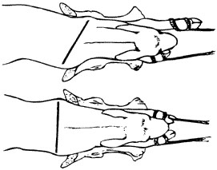

**Figure 3**  
Applying traction at delivery by "walking-out" the shoulders

1. Gradual application of traction also helps prevent damage to the cow if assistance happens to be given too early, because very slow traction will not interfere with normal dilation of the cervix.
2. Once the head and shoulders are exposed, rotate the calf a quarter of a turn to aid in the hips entering the pelvic canal. If this does not allow delivery, pull the calf downward at a 45-degree angle, or nearly parallel with the rear legs of the cow.
3. "Hip lock" can be a problem serious enough to cause loss of the calf. If it happens in a cow lying down, push the fetus back a short distance and rotate the calf a quarter turn, then apply traction to the front legs in a direction toward the cow's flank or side. This rotates the calf enough so one hip bone goes through the pelvic opening ahead of the other. If you are unable to repel or rotate the calf, place the calf's legs between the cow's hind legs and pull forward. If delivery is delayed, make sure the calf begins breathing normally as the umbilical cord will be pinched closed.
4. All posterior (rear feet first) presentations should be considered an emergency, because the umbilical cord is pinched between the fetus and pelvis early in the delivery. This means blood circulation is slowed, and the fetus may **die** or sustain brain damage unless delivery is rapid.

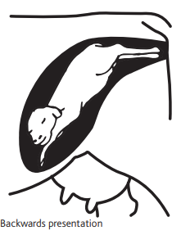

1. Attach the calving chains or ropes above the fetlock joint and be sure the birth canal is adequately lubricated, since extraction is against the normal direction of hair growth. A posterior delivery is usually eased by alternating traction on the rear legs and by rotating the fetus about a quarter of a turn to take advantage of the greatest diameter of the cow's pelvis. If delivery proves extremely difficult, a caesarean section is probably necessary and should not be delayed.