Drug | Species | Indications | Therapeutic Dose
Anti- Gaz Emulsion  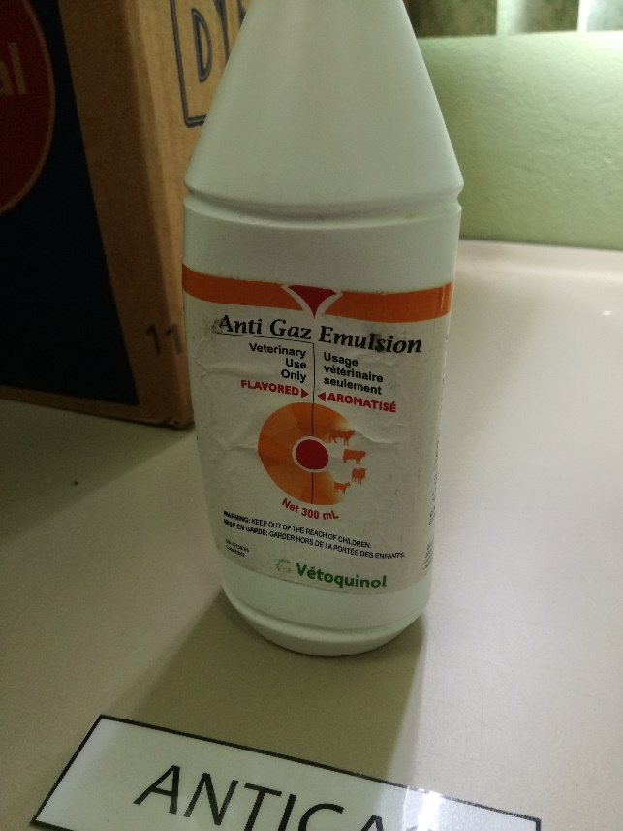 | Cattle, Sheep, Goats | An aid in the treatment of tympanism and frothy bloat in cattle, sheep and goats. It is also useful in the treatment of constipation. | Adult Cattle: 300mL administered by stomach tube in the feed or as a drench.  Young cattle, sheep and goats:  150mL administered by stomach tube in the feed or as a drench.

