Drug | Species | Indications | Therapeutic Dose | Contraindications
Universal Animal Antidote Gel (NICH UAA GEL) Easy Dose Tube  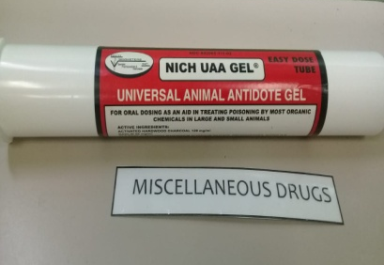 | Beef Cattle, Dairy Cattle, Horses, Sheep and Goats | For use as emergency first aid for combating poisoning caused by the accidental ingestion of insecticides, herbicides, organic chemicals, and intestinal toxins from bacteria. UAA GEL is also indicated grain overload in ruminants | Oral dose:  Large Animals: 1 to 3 mL per kilogram (2.2 lb) of body weight. A dose syringe may be used. However, the use of a stomach tube is recommended for comatose or severely debilitated animals. For cattle and horses, it is recommended that the entire contents of one tube (300 mL) of UAA be given. | UAA GEL may not be very effective in the treatment of heavy metal poisoning from lead, arsenic, or mercury.

* Protect from freezing

