Drug | Species | Indications | Therapeutic Dose | Lethal Dose/ Toxicity | Contraindications | Pharmacology | Adverse Effects
Fertiline - Gonadorelin Acetate Sterile Injectable Solution  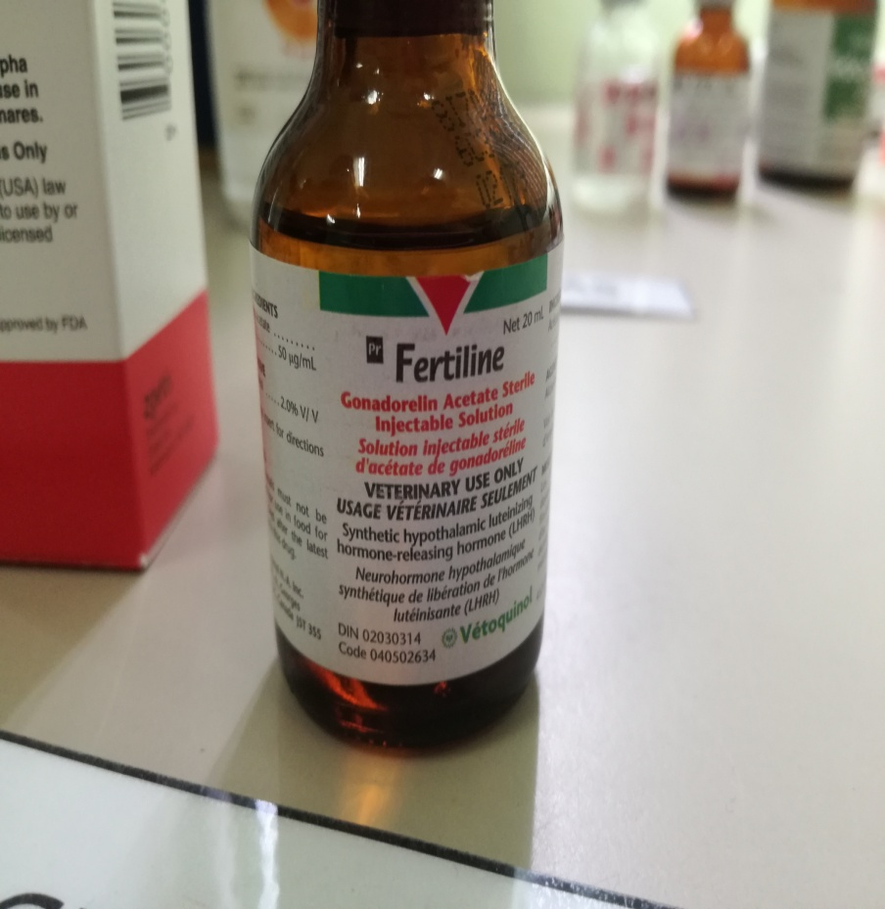 | Cattle, Sheep, Goats | For the treatment of ovarian follicular cysts in dairy cattle. Additionally, gonadorelin has been used in cattle to reduce the time interval from calving to first ovulation and to increase the number of ovulations within the first 3 months after calving. This may be particularly important in increasing fertility in cows with retained placenta.  In Europe, a synthetic analogue buserelin, has been used in horses to stimulate cyclic estrus. Its efficacy is poor when compared to an artificial light program, however. | Cattle:  To treat of ovarian cysts in cattle:  a) 100 micrograms IM or IV  b) 100 micrograms IM per cow  Sheep & Goats:  To induce ovulation outside of the breeding season in the doe:  a) 100 micrograms injected daily for 4-5 days (Smith 1986b) | In doses of up to 120 micrograms/kg, no untoward effects were noted in several  species of test animals. Gonadorelin is unlikely to cause significant adverse effects after  inadvertent overdosage | None noted. | Gonadorelin stimulates the production and the release of FSH and LH from the anterior pituitary. Secretion of endogenous GnRH from the hypothalamus is thought to be controlled by several factors, including circulating sex hormones.  Gonadorelin causes a surge-like release of FSH and LH after a single injection. In cows and ewes, this can induce ovulation, but not in estrus mares. A constant infusion of gonadorelin will initially stimulate LH and FSH release, but after a period of time, levels will return to baseline. | No reported adverse reactions were located for this agent.  Synthetically prepared gonadorelin should not cause any hypersensitivity reactions. This may not be the case with pituitary-obtained LH preparations or hCG.

