Drug | Species | Active Component(s) | Indications | Therapeutic Dose | Contraindications | Method of Use
PCE- GLYCOL  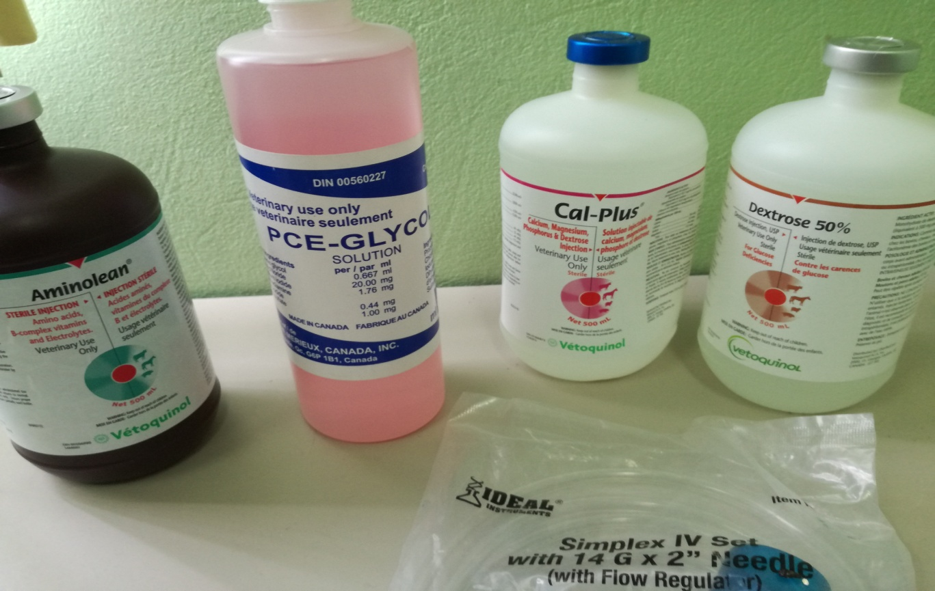 | Beef Cattle, Dairy Cattle, Sheep | - Propylene Glycol  - Choline Chloride  - Potassium Iodide  - Ethylenediamine Dihydroiodide  - Cobalt Sulfate | Glucogenic as an aid in the prevention and treatment of acetonemia. | Cattle: 175 - 225 mL daily. Begin 2 weeks prior to calving and continue for 6 weeks after calving.  Sheep: 50 - 100 mL daily. Begin 4 weeks prior to lambing and continue until lambing. | If no improvement is noted a few days after initiation of treatment, diagnosis should be reconsidered. | Administer orally in the drinking water, in the grain ration or as a drench.

