Drug | Species | Active Component(s) | Indications | Therapeutic Dose | Contraindications | Method of Use
Dextrose 50%  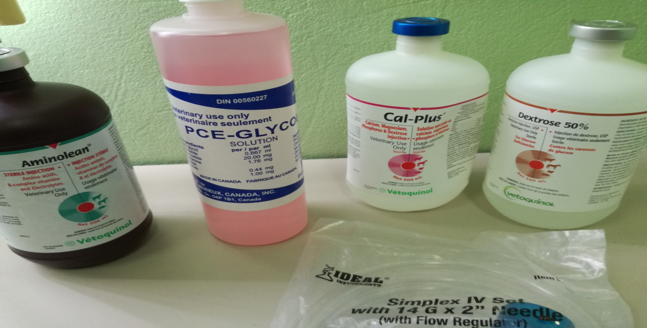 | Cattle, Horses, Sheep, Swine | - Dextrose | Treatment of insulin hypoglycemia (hyperinsulinemia or insulin shock) to restore blood glucose levels.  The solution is also indicated, after dilution, for intravenous infusion as a source of carbohydrate calories in patients whose oral intake is restricted or inadequate to maintain nutritional requirements. Slow infusion of hypertonic solutions is essential to insure proper utilization of dextrose and avoid production of hyperglycemia. | The maximum rate at which dextrose can be infused without producing glycosuria is 0.5 g/kg of body weight/hour. About 95% of the dextrose is retained when infused at a rate of 0.8 g/kg/hr.  In insulin-induced hypoglycemia, intravenous injection of 10 to 25 grams of dextrose (20 to 50 mL of 50% dextrose) is usually adequate. Repeated doses and supportive treatment may be required in severe cases. | A concentrated dextrose solution should not be used when intracranial or intraspinal hemorrhage is present, nor in the presence of  delirium tremens if the patient is already dehydrated.  Dextrose injection without electrolytes should not be administered simultaneously with blood through the same infusion set because of  the possibility that pseudoagglutination of red cells may occur. | For peripheral vein administration:  Injection of the solution should be made slowly.

