Drug | Species | Active Component(s) | Indications | Therapeutic Dose | Contraindications | Method of Use
Aminolean  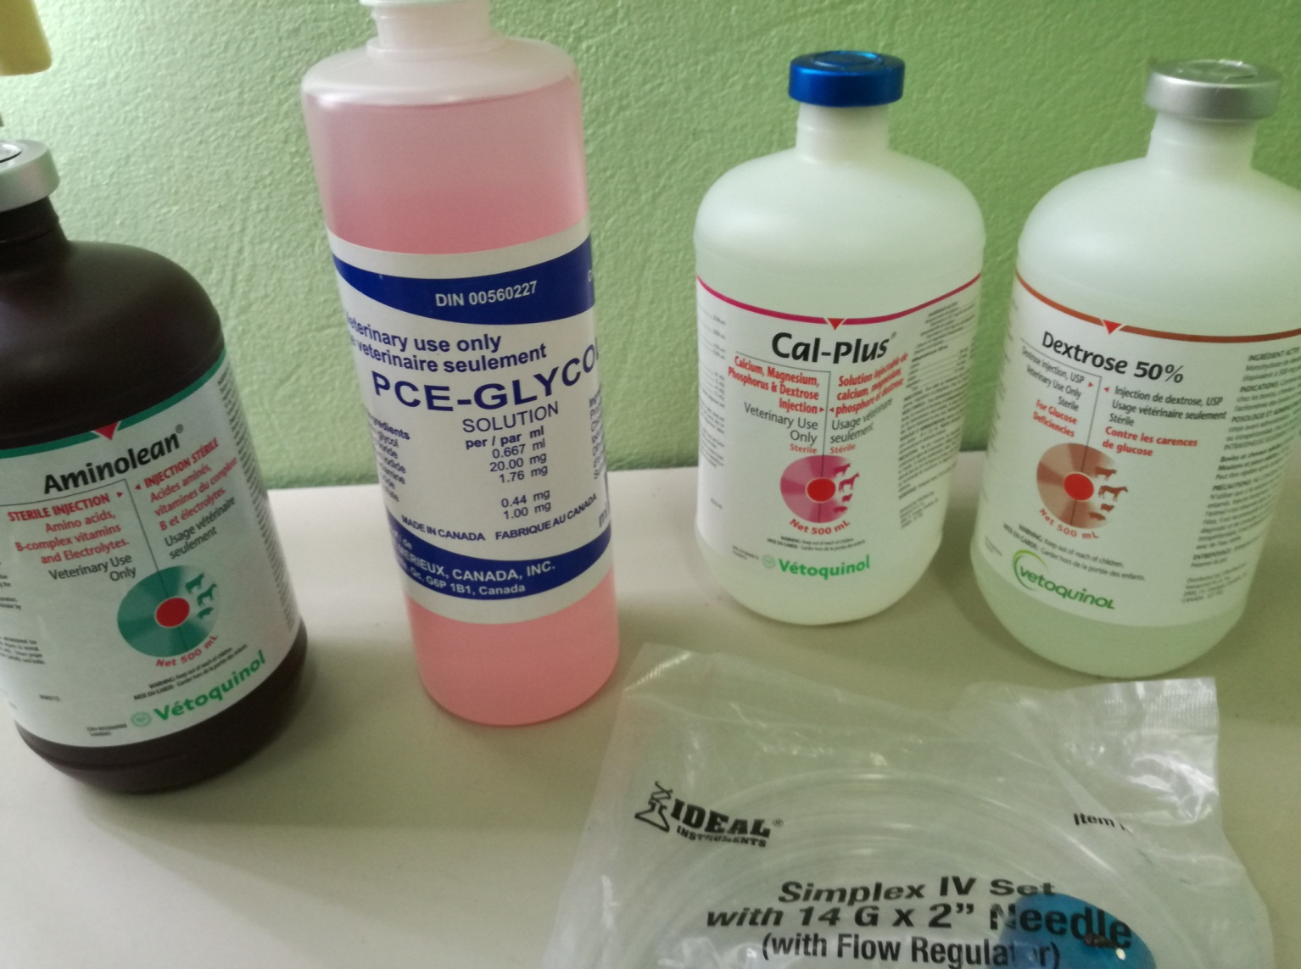 | Beef, Dairy Cattle, Horses, Swine | - Dextrose  - Calcium  - Chloride Dihydrate  - Potassium Chloride  - Magnesium Sulfate Trihydrate  - Sodium Acetate Trihydrate  - Thiamine Hcl  - Nicotinamide  - Pyridoxine Hcl  - Vitamin B12  - Riboflavin 5-Phosphate Sodium  - D-Panthenol  - Casein Hydrolysate | Aid in the supportive treatment of debilitated animals and for supportive treatment of severe diarrhea in cattle, swine and horses. Aminolean aids in counteracting the protein, electrolyte and vitamin loss associated with these conditions. | Mature Cattle, Horses & Swine: 2 mL/kg of body weight.  Calves, Foals & Piglets: 5 mL/kg of body weight. | Hypersensitivity to any ingredient in this product | Warm to body temperature prior to administration.  Administer slowly by intravenous or intraperitoneal injection in cattle and swine. Administer by intravenous injection only in horses

