Drug | Species | Indications | Therapeutic Dose | Lethal Dose/ Toxicity | Contraindications | Pharmacology | Adverse Effects
Lidocaine 2%  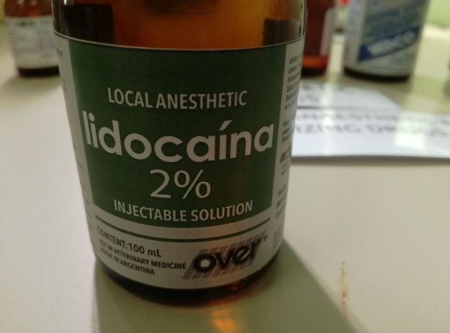 | Cattle, Horse, Swine | Most commonly used local anesthetics in large animals. It is also the drug of choice for the management of ventricular premature contractions or tachycardia.  Horses: postoperative ileus | For injection containing 20mg/mL. To prepare IV infusion using 2% veterinary solution, add 1g (50mL) of 2% solution to 1 D₅W, thus providing 1mg/mL (1,000mg/mL). With a minidrop (60 drops/mL) IV set, each drop will contain approximately 17mg. | 8 mg/kg  Signs of overdose are initial sedation, followed with increasing dosage by twitching, convulsions, coma and death | Lidocaine is contraindicated in patients with known hypersensitivity to the amide-class local anesthetics, a severe degree of SA, AV or intraventricular heart block (if not being artificially paced).  Lidocaine should be used with caution in patients with liver disease, congestive heart failure,  shock, hypovolemia, severe respiratory depression, or marked hypoxia. It should be also be used with caution in patients with bradycardia or incomplete heart block having VPC’s, unless the  heart rate is first accelerated. Patients susceptible to developing malignant hyperthermia should receive lidocaine with intensified monitoring. | Lidocaine is considered to be a class IB (membrane-stabilizing)  antidysrhythmic agent. It is thought that lidocaine acts by combining with fast sodium channels when inactive which inhibits recovery after repolarization. Class IB agents demonstrate rapid rates of attachment and dissociation to sodium channels. At therapeutic levels, lidocaine causes phase 4 diastolic depolarization attenuation, decreased automaticity, and either a decrease or no change in membrane responsiveness and excitability. These effects will occur at serum levels that will not inhibit the automaticity of the SA node, and will have little effect on AV node  conduction or His-Purkinje conduction.  Lidocaine apparently has some enhancing effects on intestinal motility in patients with  postoperative ileus. The mechanism for this effect is not well understood, but probably involves  more than just blocking increased sympathetic tone. | At usual doses and if the serum level remains within the proposed therapeutic range (1 - 5 micrograms/ml), serious adverse reactions are quite rare. The most common adverse effects reported are dose related (serum level) and mild. CNS signs include  drowsiness, depression, ataxia, muscle tremors, etc. Nausea and vomiting may occur, but are  usually transient. Adverse cardiac effects generally only occur at high plasma concentrations and are usually associated with PR and QRS interval prolongation and QT interval shortening.  Lidocaine may increase ventricular rates if used in patients with atrial fibrillation. If an IV bolus is given too rapidly, hypotension may occur.

