Drug | Species | Indications | Therapeutic Dose | Lethal Dose/ Toxicity | Contraindications | Pharmacology | Adverse Effects
Ketamin 10%  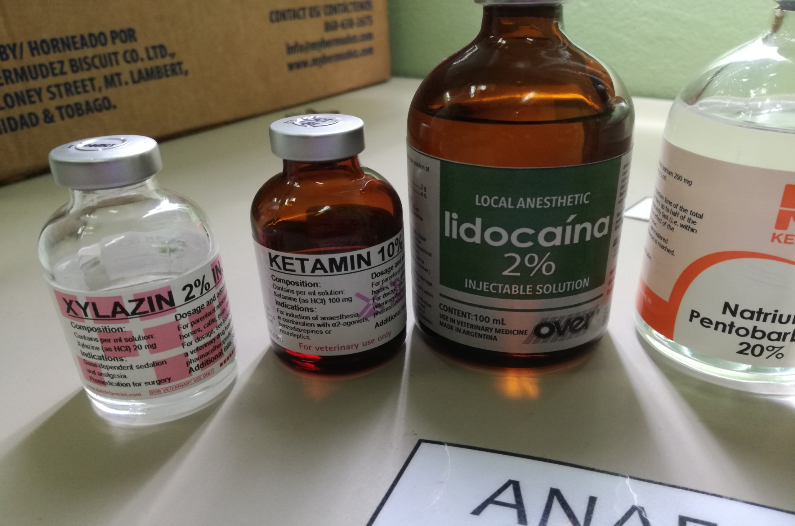 | Cattle, Horses, Sheep, Goats, Swine | Rapid- acting, non- barbiturate general anesthetic. It is classified as a dissociative anesthetic and is accompanied by marked analgesia in most species. May be used in combination with a tranquilizing agent such as Xylazine in large animals for induction of general anesthesia for endotracheal intubation, also for short procedures such as a surgical repair of minor wounds or castration of stallions or colts. Muscle relaxation with Ketamine alone is poor. | Cattle:  Premedicate with atropine and xylazine, then ketamine 2.0 mg/kg IV bolus. After sedation, 2.2 mg/kg IV  Horses:  For field anesthesia: Sedate with xylazine (1.0 mg/kg IV; 2.0 mg/kg IM) given 5-10 minutes (longer for IM route) before induction of anesthesia with ketamine (2 mg/kg  IV).  Swine:  a) Give atropine, then ketamine at 11 mg/kg IM. To prolong anesthesia and increase  analgesia give additional ketamine 2 - 4 mg/kg IV. | Ketamine is considered to have a wide therapeutic index (approximately 5 times greater when compared to pentobarbital). When given in excessive doses or too rapidly,  significant respiratory depression may occur. Treatment using mechanically assisted respiratory  support is recommended versus the use of analeptic agents. | Ketamine is contraindicated in patients who have exhibited  prior hypersensitivity reactions to it and in animals to be used for human consumption. Its use in  patients with significant hypertension, heart failure, and arterial aneurysms could be hazardous.  Ketamine can cause increases in CSF pressure and it should not be used in cases with elevated  pressures or when head trauma has occurred. Because of its supposed epileptogenic potential, it  should generally not be used (unless very cautiously) in animals with preexisting seizure  disorders. As myelography can induce seizures, ketamine should be used cautiously in animals  undergoing this procedure. | Ketamine is a rapid acting general anesthetic that also has significant analgesic activity and a lack of cardiopulmonary depressant effects. It is thought to induce both anesthesia  and amnesia by functionally disrupting the CNS through over stimulating the CNS or inducing a cataleptic state. Ketamine inhibits GABA, and also may block serotonin, norepinephrine, and  dopamine in the CNS. The thalamoneocortical system is depressed while the limbic system is  activated. It induces anesthetic stages I & II, but not stage III. In cats, it causes a slight hypothermic effect as body temperatures decrease on average by 1.6°C after therapeutic doses.  Effects on muscle tone are described as being variable, but ketamine generally either causes no changes in muscle tone or increased tone. Ketamine does not abrogate the pinnal and pedal  reflexes, nor the photic, corneal, laryngeal or pharyngeal reflexes.  Ketamine’s effects on the cardiovascular system include increased cardiac output, heart rate, mean aortic pressure, pulmonary artery pressure, and central venous pressure. Its effects on total  peripheral resistance are described as being variable. Cardiovascular effects are secondary to increased sympathetic tone; ketamine has negative inotropic effects if the sympathetic system is blocked. | Respiratory depression, following high doses, emesis, vocalization, erratic and prolonged recovery, dyspnea, spastic jerking movements, convulsions, muscular tremors, hypertonicity, opisthotonos and cardiac arrest.

