Drug | Species | Indications | Therapeutic Dose | Lethal Dose/ Toxicity | Contraindications | Pharmacology | Adverse Effects
Combistress ®  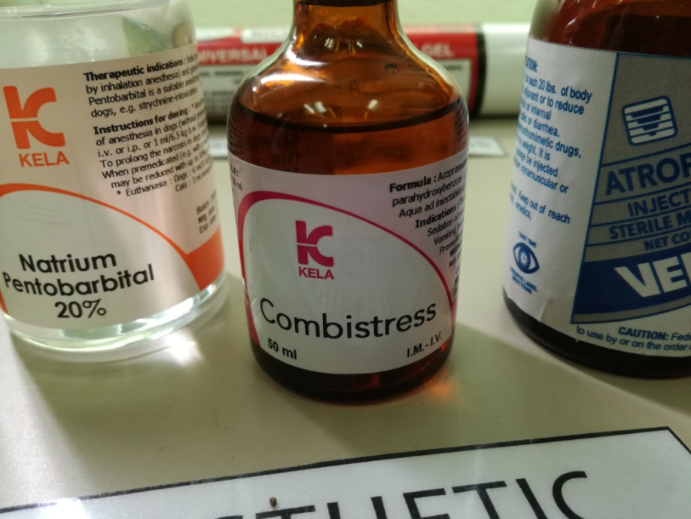 | Cattle, Horses, Sheep, Goats, Swine | Tranquilization during shipment. Sedation of nervous or aggressive animals. Vomiting associated with motion sickness. Premedication in general or local anesthesia. | Cattle, horses, sheep, goats:  0.05 mg/kg or 0.125 ml/50 kg I.V.  0.05 - 0.1 mg/kg or 0.125 - 0.25 ml/50 kg b.w. I.M.  Swine:  0.1-0.2 mg/kg IV, IM, SC | The LD₅₀ in mice is 61 mg/kg after IV dosage and 257 mg/kg after oral dose. | Cardiac disease, hypovolemia, hypotension or shock. Coagulopathies or thrombocytopenia. Some researchers have reported that acepromazine has anticonvulsant activity, but in veterinary medicine it is generally felt that  phenothiazines should not be used in epileptic animals or those susceptible to seizures (e.g., postmyelography)  as it may precipitate seizures. | Acepromazine is a phenothiazine neuroleptic agent. While the exact mechanisms of action are not fully understood, the phenothiazines block post-synaptic dopamine receptors in the CNS and may also inhibit the release of and increase the turnover rate of dopamine. They are thought to depress portions of the reticular activating system which assists in the control of body temperature, basal metabolic rate, emesis, vasomotor tone, hormonal balance, and alertness. Additionally, phenothiazines have varying degrees of anticholinergic, antihistaminic, antispasmodic, and alpha-adrenergic blocking effects.  The primary desired effect for the use of acepromazine in veterinary medicine is its tranquilizing action. Additional pharmacologic actions that acepromazine possess, include  antiemetic, antispasmodic, and hypothermic actions.  Acepromazine may decrease respiratory rates, but studies have demonstrated that little or no effect occurs with regard to the blood gas picture, pH or oxyhemoglobin saturation. A dose dependent decrease in hematocrit is seen within 30 minutes after dosing in the horse. | Acepromazine’s effect on blood pressure (hypotension) is well described and an important consideration in therapy. This effect is thought to be mediated by both central mechanisms and also through the alpha-adrenergic actions of the drug.  Cardiovascular collapse (secondary to bradycardia and hypotension) has been described in all major species. In male large animals, acepromazine may cause protrusion of the penis. In horses, this effect may last 2 hours. Stallions should be given acepromazine with caution as injury to the penis can occur with resultant swelling and permanent paralysis of the penis retractor muscle. Other symptoms that have been reported in horses include excitement, restlessness, sweating, trembling, tachypnea, tachycardia and, rarely, seizures and recumbency.  While acepromazine is a good tranquilizer, its effects of causing penis extension in horses and  prolapse of the membrana nictitans in horses and dogs, may make its use unsuitable for show animals. There are also ethical considerations regarding the use of tranquilizers prior to showing an animal or having the animal examined before sale.  Occasionally an animal may develop the contradictory symptoms of aggressiveness and  generalized CNS stimulation after receiving acepromazine. IM injections may cause transient  pain at the injection site.

