Drug | Species | Indications | Therapeutic Dose
Multivit Injection  (Vitamins A, D3, E, B1, B2, B6, B12, calcium glycerophosphate, niclosamide)  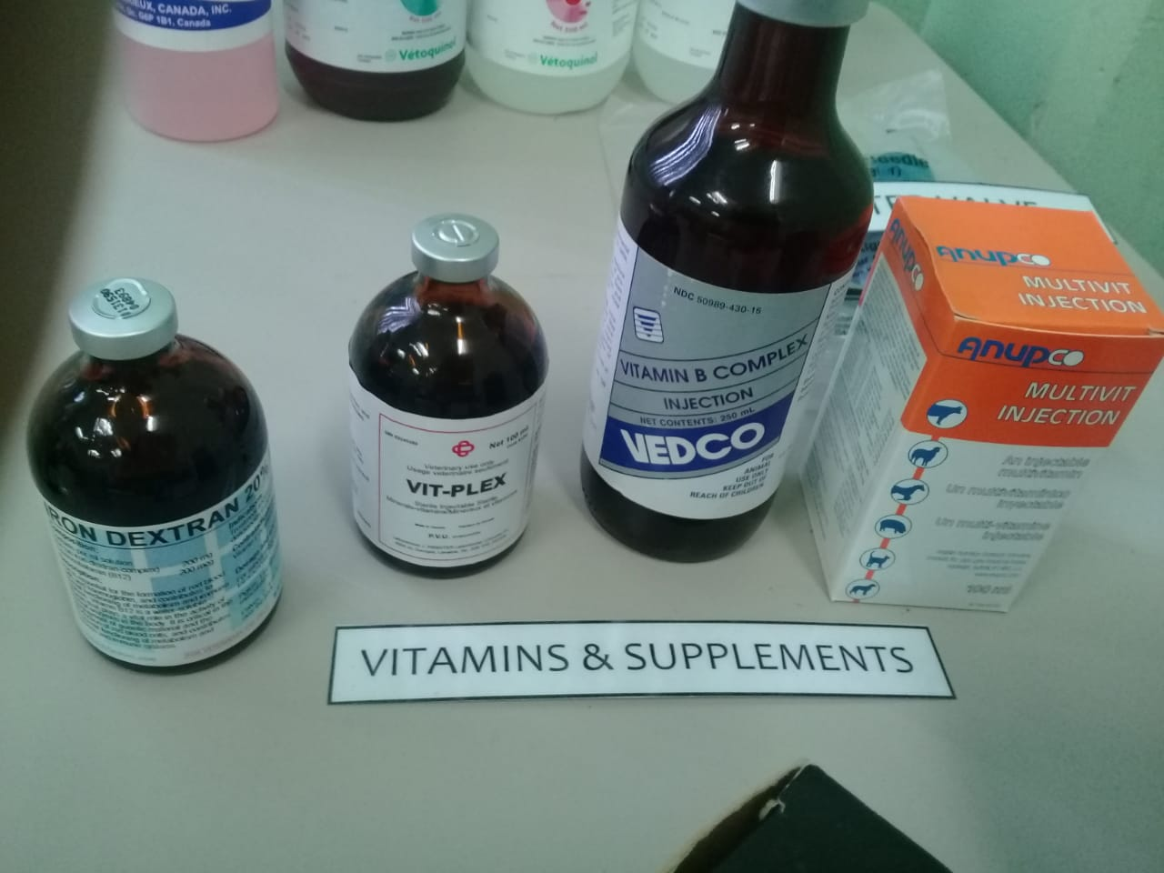 | Cattle, Horses, Sheep, Goats, Swine | Polyvitamin and minerals for the prevention and correction of vitamin and mineral deficiencies | Horses, cattle, swine: 4-8 mL per day  Foals, sheep, calves: 2-3 mL per day

