Drug | Species | Indications | Therapeutic Dose | Method of Use
VEDCO Vitamin B Complex  (Vitamins B1, B2, B6, B12)  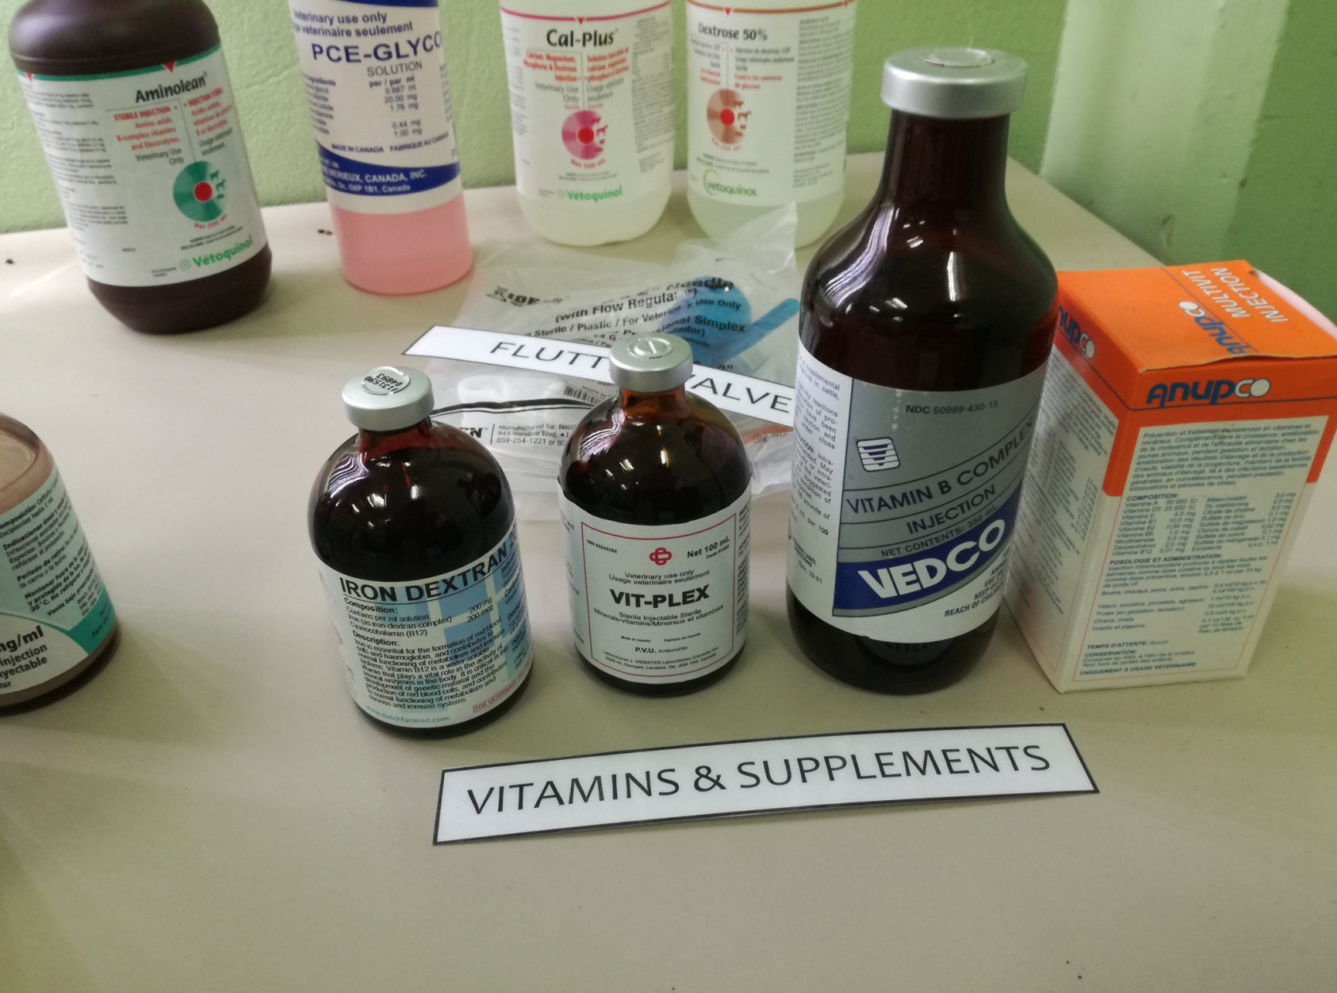 | Cattle, Sheep, Horses | As a supplemental source of B complex vitamins for use in the treatment of deficiencies of these vitamins in cattle, sheep and horses. | Adult Cattle: 1 to 2 mL per 100 pounds of body weight.  Calves, Swine and Sheep: 5 mL per 100 pounds of body weight  Horses: 5-10mL intramuscular injection | Intramuscular or intravenous administration

