Drug | Species | Indications | Therapeutic Dose | Method of Use
Vit- Plex  (Cobalt Gluconate, Copper Gluconate,  Ferrous Ammonium Citrate, Liver Extract, Nicotinamide, Soluble Vitamins: B1, B12, B2, B3, B5, B6)  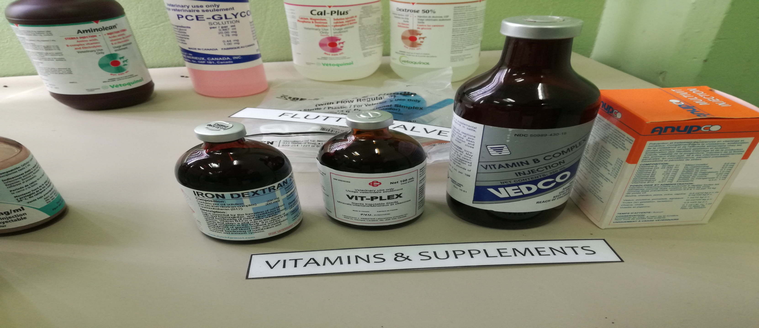 | Cattle, Horse, Swine, Sheep | Polyvitamin and minerals for the prevention and correction of vitamin and mineral deficiencies | Horses, cattle, swine: 4-8 mL per day  Foals, sheep, calves: 2-3 mL per day | Intramuscular or intravenous administration

