Drug | Species | Indications | Therapeutic Dose | Lethal Dose/ Toxicity | Contraindications | Pharmacology | Adverse Effects
Trisulkel® 240  (Trimethoprim/ Sulfa-methoxazole)  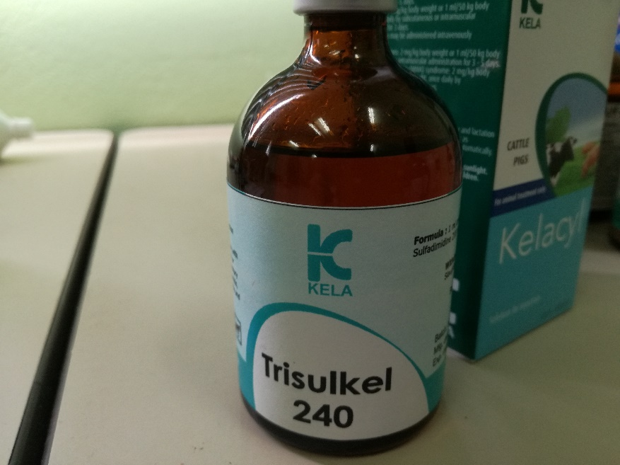 | Horses, Cattle | Infections of the urinary and respiratory tract, pharyngitis, septicemia, mastitis, metritis, strangles in horses, arthritis and dermal infections. | 1mL/ 10-15kg body weight by I.M., S.C. or slow I.V. administration. Injection to be repeated if necessary with 12 to 24-hour intervals. | Manifestations of an acute overdosage can include symptoms of  GI distress (nausea, vomiting, diarrhea), CNS toxicity (depression, headache, and confusion),  facial swelling, bone marrow depression and increases in serum aminotransferases. Oral  overdoses can be treated by emptying the stomach (following usual protocols) and initiating  symptomatic and supportive therapy. Acidification of the urine may increase the renal  elimination of trimethoprim, but could also cause sulfonamide crystalluria, particularly with  sulfadiazine containing products. Complete blood counts (and other laboratory parameters)  should be monitored as necessary. Bone marrow suppression associated with chronic overdoses  may be treated with folinic acid (leucovorin) if severe. Peritoneal dialysis is not effective in  removing TMP or sulfas from the circulation. | Not to be used in horses with liver parenchymal damage, blood dyscrasis, or history of sulfonamide sensitivity. Not to be used in animals intended for food. Safety of trimethoprim/sulfa has not been clearly established in pregnant animals. Reports of  teratogenicity (cleft palate) have been reported in some rat studies. Fetal mortality was also  increased in rabbits receiving high doses of trimethoprim | Alone, sulfonamides are bacteriostatic agents and trimethoprim is bactericidal,  but in combination, the potentiated sulfas are bactericidal. Potentiated sulfas sequentially inhibit enzymes in the folic acid pathway, thereby inhibiting bacterial thymidine synthesis. The sulfonamide blocks the conversion of para-aminobenzoic acid (PABA) to dihydrofolic acid (DFA), and trimethoprim blocks the conversion of DFA to tetrahydrofolic acid by inhibiting  dihydrofolate reductase.  The in vitro optimal ratio for most susceptible bacteria is approximately 1:20  (trimethoprim:sulfa), but synergistic activity can reportedly occur with ratios of 1:1 - 1:40. The serum concentration of the trimethoprim component is considered to be more important than the sulfa concentration. For most susceptible bacteria, the MIC’s for TMP are generally above 0.5 micrograms/ml.  The potentiated sulfas have a fairly broad spectrum of activity. Gram positive bacteria that are generally susceptible include most streptococci, many strains of staphylococcus and Nocardia.  Approximately 30% of strains tested of Streptococcus zooepidemicus are resistant to TMP/Sulfa in horses. Many gram negative organisms of the family Enterobacteriaceae are susceptible to the potentiated sulfas, but not Pseudomonas aeruginosa. Some protozoa (Pneumocystis carinii,  Coccidia and Toxoplasma) are also inhibited by the combination. Potentiated sulfas reportedly have little activity against most anaerobes, but opinions on this vary.  Resistance will develop slower to the combination of drugs than to either one alone. In gram negative organisms, resistance is usually plasmid-mediated. | In horses, transient pruritus has been noted after intravenous injection. Oral therapy has resulted in diarrhea development in some horses. Previous administration of potentiated sulfas have been  implicated in increasing the mortality rate of equine diarrhea. If the 48% injectable product is injected IM, SC, or extravasates after IV administration, swelling, pain and minor tissue damage  may result. Hypersensitivity reactions and hematologic effects (anemias, thrombocytopenia, or  leukopenias) may also be seen; long term therapy should include periodic hematologic monitoring.

