Drug | Species | Indications | Therapeutic Dose | Contraindications | Pharmacology
Scourban Plus®  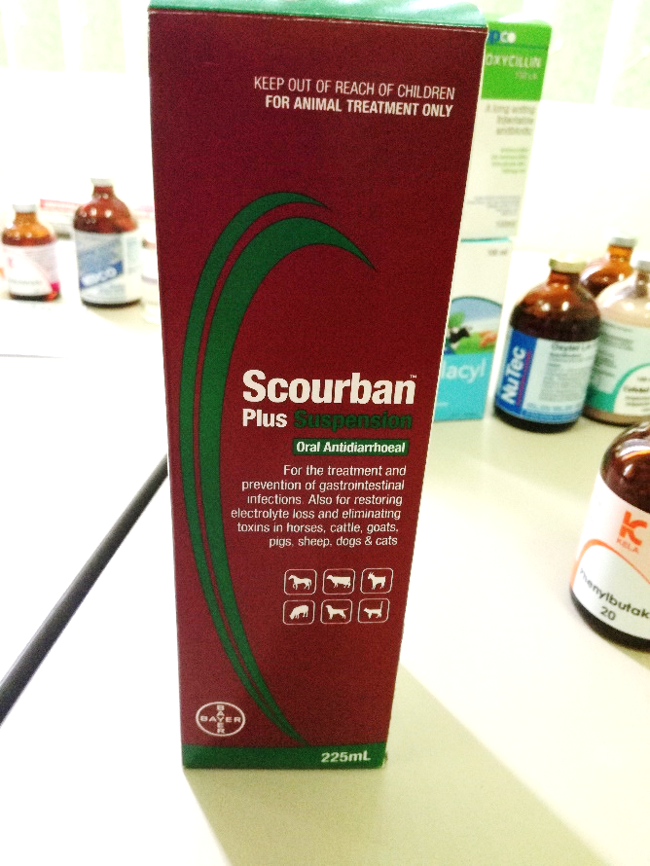 | Horses, Cattle, Swine, Sheep, Goats | Prevention and treatment of intestinal infections of bacterial origin in horses, cattle, goats and pigs. Prevents and treats scours.  Soothes and protects the gut. Contains electrolytes and glycine to restore fluid balance. | Calves, Pigs & Horses: 30ml/25kg orally  Piglets: 1 - 2ml  Sheep/Goats: 13ml/25 kg | This product is contraindicated for use in animals with known sulfonamide sensitivity, liver damage or blood dyscrasias | Sulphonamide antibiotics exert antibacterial effect. Electrolytes and glycine assist restoration of fluid balance. Hyoscine hydrobromide acts as an antispasmodic. Kaolin and pectin absorb bacterial toxins and provide protective coating in inflamed mucosa

* Withdrawal period: MEAT: 14 days till slaughter; MILK: 35 days

