Drug | Species | Indications | Therapeutic Dose | Lethal Dose/ Toxicity | Contraindications | Pharmacology | Adverse Effects
Oxytet LA 10% (Oxytetracycline base 100mg/mL)  Oxytet LA 20%  (Oxytetracycline base 200mg/mL)  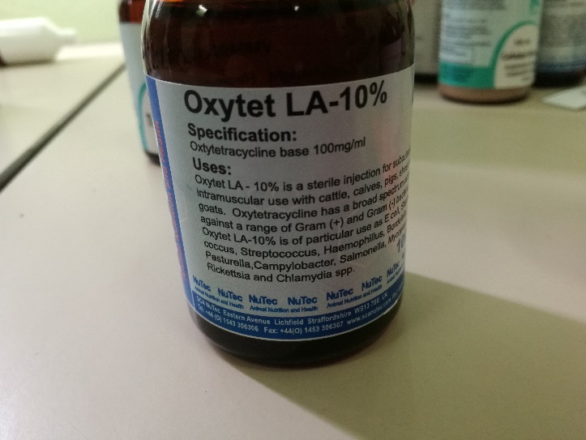 | Cattle, Horses, Swine | Oxytetracycline products are approved for use in calves, non-lactating dairy cattle, beef cattle, swine. Used as a broad spectrum antibiotic against gram + and gram - bacteria | Cattle:  5 - 10 mg/kg IM q24h or 20 mg/kg q48-72h IM;  2.5 - 5 mg/kg IV q24h  Foals:  5 - 10 mg/kg IV q12h  Swine:  6- 11 mg/kg IV or IM; 10 - 20 mg/kg PO q6h | Tetracyclines in high levels can exert an antianabolic effect which can cause an increase in BUN and/or hepatotoxicity, particularly in patients with preexisting renal dysfunction. As renal function deteriorates secondary to drug accumulation, this effect may be exacerbated. | Patients hypersensitive to it or other tetracyclines. Because tetracyclines can retard fetal skeletal  development and discolor deciduous teeth, they should only be used in the last half of pregnancy when the benefits outweigh the fetal risks. Oxytetracycline and tetracycline are considered to be more likely to cause these abnormalities than either doxycycline or minocycline.  In patients with renal insufficiency or hepatic impairment, oxytetracycline and tetracycline must  be used cautiously. Lower than normal dosages are recommended with enhanced monitoring of renal and hepatic function. Avoid concurrent administration of other nephrotoxic or hepatotoxic  drugs if tetracyclines are administered to these patients. Monitoring of serum levels should be  considered if long-term therapy is required. | Tetracyclines generally act as bacteriostatic antibiotics and inhibit protein synthesis by reversibly binding to 30S ribosomal subunits of susceptible organisms, thereby  preventing binding to those ribosomes of aminoacyl transfer-RNA. Tetracyclines also are believed to reversibly bind to 50S ribosomes and additionally alter cytoplasmic membrane permeability in susceptible organisms. In high concentrations, tetracyclines can also inhibit protein synthesis by mammalian cells.  As a class, the tetracyclines have activity against most mycoplasma, spirochetes (including the Lyme disease organism), Chlamydia, and Rickettsia. Against gram positive bacteria, the tetracyclines have activity against some strains of staphylococci and streptococci, but resistance of these organisms is increasing. Gram positive bacteria that are usually covered by tetracyclines, include Actinomyces sp., Bacillus anthracis, Clostridium perfringens and tetani, Listeria monocytogenes, and Nocardia. Among gram negative bacteria that tetracyclines usually have in vitro and in vivo activity against include Bordetella sp., Brucella, Bartonella, Haemophilus sp., Pasturella multocida, Shigella, and Yersinia pestis. Many or most strains of E. coli, Klebsiella, Bacteroides, Enterobacter, Proteus and Pseudomonas aeruginosa are resistant to the tetracyclines. While most strains of Pseudomonas aeruginosa show in vitro resistance to tetracyclines, those compounds attaining high urine levels (e.g., tetracycline, oxytetracycline) have been associated with clinical cures in dogs with UTI secondary to this organism.  Oxytetracycline and tetracycline share nearly identical spectrums of activity and patterns of cross-resistance and a tetracycline susceptibility disk is usually used for in vitro testing for  oxytetracycline susceptibility. | Oxytetracycline and tetracycline given to young animals can cause discoloration of bones and teeth to a yellow, brown, or gray color. High dosages or chronic administration may delay bone growth and healing.  In ruminants, high oral doses can cause ruminal microflora depression and ruminoreticular  stasis. Rapid intravenous injection of undiluted propylene glycol-based products can cause  intravascular hemolysis with resultant hemoglobinuria.

