|  |  |  |  |  |  |  |  |
| --- | --- | --- | --- | --- | --- | --- | --- |
| **Drug** | **Species** | **Indications** | **Therapeutic Dose** | **Lethal Dose/ Toxicity** | **Contraindications** | **Pharmacology** | **Adverse Effects** |
| Kelacyl®  (Marbofloxacin) | Cattle, Swine | In cattle:  - treatment of respiratory infections caused by strains of *Histophilus somni,* *Mannheimia haemolytica*, *Mycoplasma bovis, Pasteurella multocida* susceptible to marbofloxacin.  - treatment of acute mastitis caused by strains of Escherichia coli susceptible to marbofloxacin during the lactation period.  In pigs:  - treatment of Postpartum Dysgalactia Syndrome –PDS-(Metritis Mastitis Agalactia syndrome), caused by bacterial strains susceptible to marbofloxacin. | Cattle: Intramuscular, subcutaneous or intravenous  -Respiratory infections:  8 mg marbofloxacin/kg body weight (2 ml veterinary medicinal product/25 kg body weight) in a single injection by the intramuscular route. In cases of respiratory infections caused by *Mycoplasma bovis*, the recommended dose is 2 mg marbofloxacin/kg body weight (1 ml veterinary medicinal product/50 kg body weight), in a single daily injection for 3 to 5 consecutive days, by the intramuscular or subcutaneous route. The first injection may be given by the intravenous route.  - Acute mastitis: I.M. or S.C.: 2 mg marbofloxacin/kg body weight (1 ml veterinary medicinal product/50 kg body weight) in a single daily injection, for 3 consecutive days. The first injection may also be given by the intravenous route  **Pigs**: Intramuscular  2mg marbofloxacin/kg body weight (1 ml veterinary medicinal product/50 kg body weight) in a single daily injection, for 3 consecutive days. | No signs of overdosage have been observed after administration of 3 times the recommended dose. Signs such as acute neurological disorders may occur when the dose is exceeded. These signs should be treated symptomatically | Do not use in cases where the pathogen involved is resistant to other fluoroquinolones (cross resistance).  Do not use in cases of hypersensitivity to the active substance, to any other quinolone or to any of the excipients. | Marbofloxacin is a synthetic, bactericidal antimicrobial, belonging to the fluoroquinolone group which acts by inhibition of DNA gyrase. It has a broad-spectrum activity in vitro against Gram-negative bacteria (*E. coli, Histophilus somni, Mannheimia haemolytica and Pasteurella multocida*) and against *Mycoplasma (Mycoplasma bovis).* Resistance to *Streptococcus* may occur.  Strains with MIC ≤ 1 µg/ml are susceptible to marbofloxacin whereas strains with MIC ≥ 4 µg/ml are resistant to marbofloxacin. Resistance to fluoroquinolones occurs by chromosomal mutation with three mechanisms: decrease of the bacterial wall permeability, expression of efflux pump or mutation of enzymes responsible for molecule binding. | Transitory inflammatory lesions can occur very rarely at the injection site, without clinical impact, when administered via the intramuscular or subcutaneous route. Administration by the intramuscular route may cause very rarely transient local reactions such as pain and swelling at the injection site and inflammatory lesions which may persist for at least 12 days after injection. However, in cattle, the subcutaneous route was shown to be better tolerated locally than the intramuscular route. Therefore, the subcutaneous route is recommended in heavy cattle. The frequency of adverse reactions is defined using the following convention: - very common (more than 1 in 10 animals treated displaying adverse reaction(s)) - common (more than 1 but less than 10 animals in 100 animals treated) - uncommon (more than 1 but less than 10 animals in 1,000 animals treated) - rare (more than 1 but less than 10 animals in 10,000 animals treated) - very rare (less than 1 animal in 10,000 animals treated, including isolated reports). |

* Safety of the veterinary medicinal product at 2 mg/kg body weight has been established in pregnant cows or in sucking calves and piglets when used in cows and sows. Can be used during pregnancy and lactation.

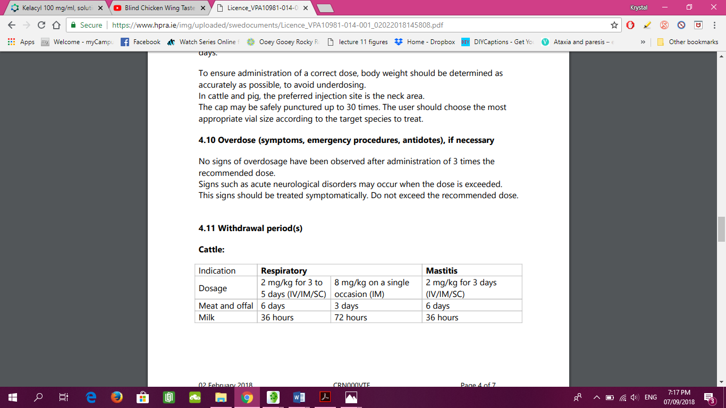

Pigs: Meat and offal: 4 days