Drug | Species | Indications | Therapeutic Dose | Lethal Dose/ Toxicity | Contraindications | Pharmacology | Adverse Effects
Gentamycin 100  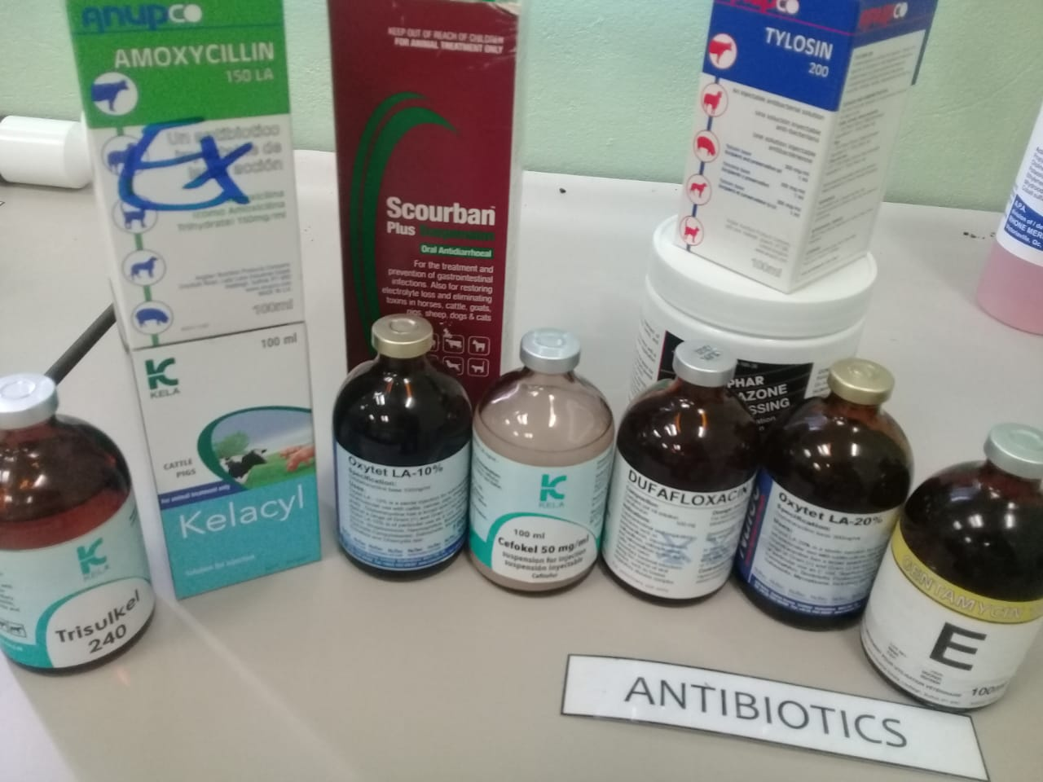 | Horse, Sheep, Swine | Although routinely used parenterally in horses, gentamicin is only approved for  intrauterine infusion in that species. Oral products are approved for gastrointestinal infections in  swine.  Used against wide variety of bacteria, especially Gram-negative aerobic bacilli and Staph. strains in horses, sheep and pigs. Usually the only effective agent against severe Gram-negative infections. | Horses: 6.6mg/kg, IV/IM (q24). Foals: 11-15 mg/kg q24  Pigs: 5mg/kg, PO/IM in neonates; 1.1mg/kg in weanlings PO. 2.2mg/kg to treat swine dysentery  Sheep: 5mg/kg IM | Should an inadvertent overdosage be administered, three  treatments have been recommended. Hemodialysis is very effective in reducing serum levels of the drug, but is not a viable option for most veterinary patients. Peritoneal dialysis also will reduce serum levels, but is much less efficacious. | Aminoglycosides are contraindicated in patients who are hypersensitive to them. Because these drugs are often the only effective agents in severe gram-negative infections there are no other absolute contraindications to their use.  However, they should be used with extreme caution in patients with preexisting renal disease with concomitant monitoring and dosage interval adjustments made. Other risk factors for the development of toxicity include age (both neonatal and geriatric patients), fever, sepsis and dehydration.  Aminoglycosides should be used with caution in patients with neuromuscular disorders (e.g.,  myasthenia gravis) due to their neuromuscular blocking activity.  Because aminoglycosides are eliminated primarily through renal mechanisms, they should be used cautiously, preferably with serum monitoring and dosage adjustment in neonatal or geriatric animals. | Gentamicin has a mechanism of action and spectrum of activity (primarily gram negative aerobes) similar to the other aminoglycosides. Gentamicin resistance by certain bacteria, principally Klebsiella, E. coli and Pseudomonas aeruginosa is a continuing concern for many areas.  However, most strains of gentamicin-resistant bacteria of these species remain susceptible to amikacin. | The aminoglycosides are infamous for their nephrotoxic and ototoxic effects. The nephrotoxic (tubular necrosis) mechanisms of these drugs are not completely understood, but are probably related to interference with phospholipid metabolism in the lysosomes of proximal renal tubular cells, resulting in leakage of proteolytic enzymes into the cytoplasm. Nephrotoxicity is usually manifested by increases in BUN, creatinine, nonprotein nitrogen in the serum and decreases in urine specific gravity and creatinine clearance. Proteinuria and cells or casts may also be seen in the urine. Nephrotoxicity is usually reversible once the drug is discontinued. While gentamicin may be more nephrotoxic than the other aminoglycosides, the incidences of nephrotoxicity with all of these agents require equal caution and monitoring.  Ototoxicity (8th cranial nerve toxicity) of the aminoglycosides can be manifested by either  auditory and/or vestibular symptoms and may be irreversible. Vestibular symptoms are more frequent with streptomycin, gentamicin, or tobramycin.  The aminoglycosides can also cause neuromuscular blockade, facial edema, pain/inflammation  at injection site, peripheral neuropathy and hypersensitivity reactions.

