Drug | Species | Indications | Therapeutic Dose | Contraindications | Warnings | Adverse Effects
Equi- Phar Nitrofurazone Soluble Dressing- An Anti-Bacterial Preparation for Tropical Application  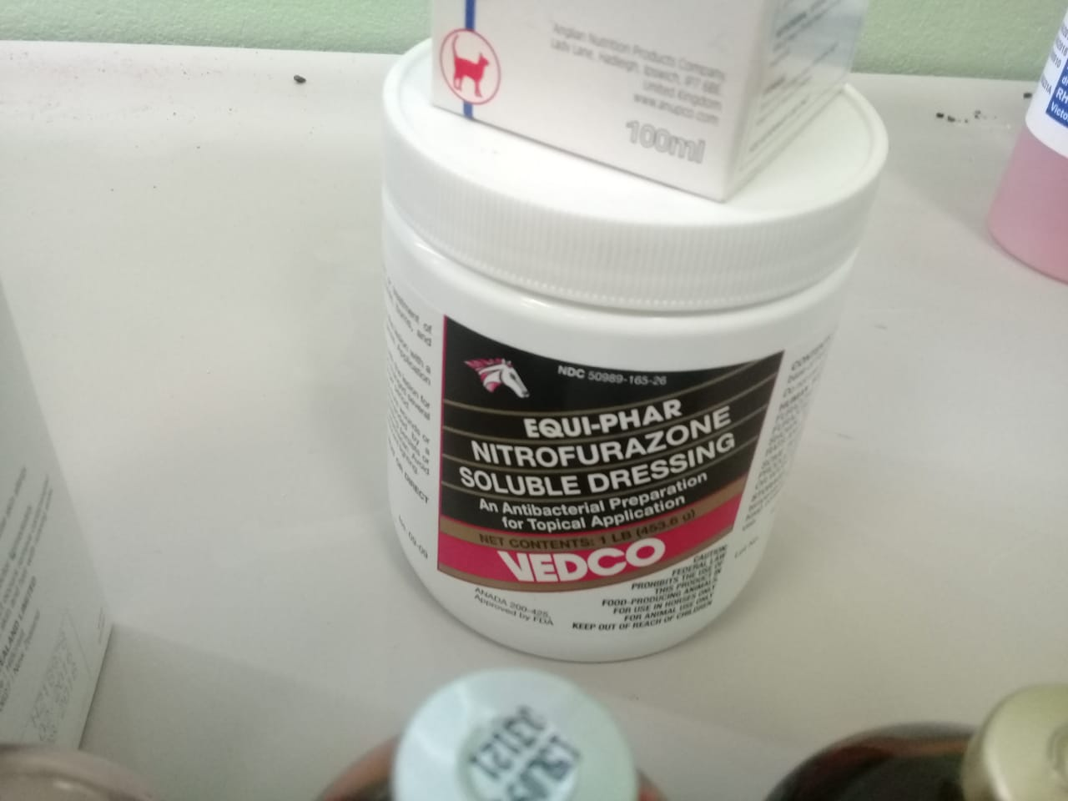 | Horses | For the prevention or treatment of surface bacterial infections of wounds, burns, and cutaneous ulcers, by organisms sensitive to nitrofurazone. | Apply directly on the lesion with a spatula or on a piece of gauze. Application of a bandage is optional. This preparation should be in contact with the lesion for at least 24 hours. The dressing may be changed several times daily or left on the lesion for a longer period. | Not used for horses that will be intended as food. | Carcinogenesis: Nitrofurazone, the active ingredient of Nitrofurazone Soluble Dressing, has been shown to produce mammary tumors in rats and ovarian tumors in mice. Additionally, some people may be hypersensitive to the product. Either wear gloves when applying, or wash hands afterwards.  Keep away from excessive heat or direct sunlight. Avoid exposure to alkaline material and strong fluorescent lighting. | In case of deep or puncture wounds, or serious burns, consult a veterinarian. If redness, irritation, or swelling persists or increases, discontinue use and consult a veterinarian.

