Drug | Species | Indications | Therapeutic Dose | Contraindications | Pharmacology
Dufafloxacin 10%  (Enrofloxacin)  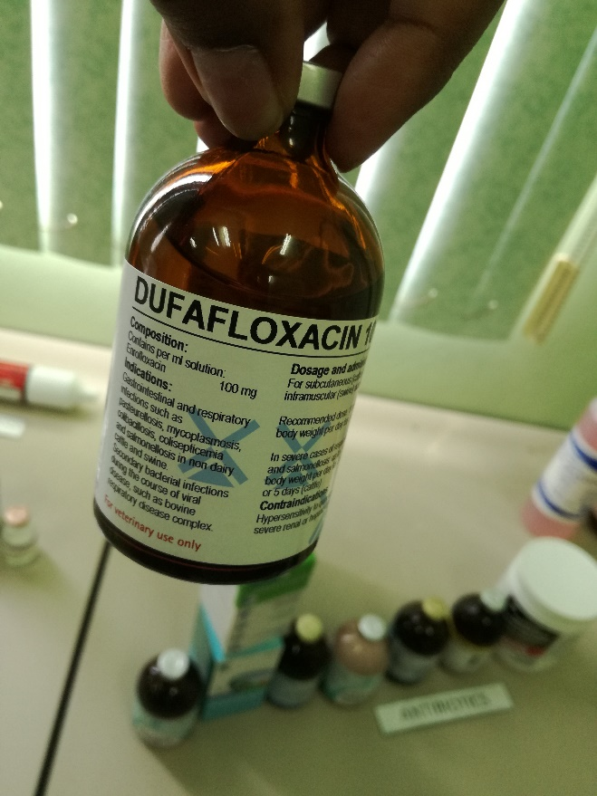  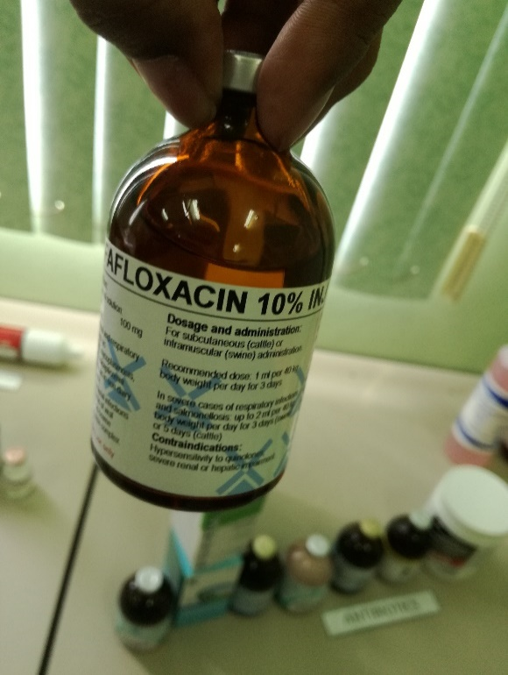 | Cattle, Swine | Gastrointestinal and respiratory infections such as pasteurellosis, mycoplasmosis, colibacillosis, colisepticemia and salmonellosis in non dairy cattle and swine. Secondary bacterial infections during the course of viral disease, such as bovine respiratory disease complex. | Subcutaneous for cattle or intramuscular for swine administration.  1mL per 40kg body weight per day for 3 days.  In severe cases of respiratory infection and salmonellosis: up to 2mL per 40kg body weight per day for 3 days (swine) or 5 days (cattle). | Hypersensitivity to quinolones, severe renal or hepatic impairment. | Enrofloxacin is a bactericidal agent. The bactericidal activity of enrofloxacin is concentration dependent, with susceptible bacteria cell death occurring within 20-30 minutes of exposure. Enrofloxacin has demonstrated a significant post-antibiotic effect for both gram – and + bacteria and is active in both stationary and growth phases of bacterial replication.  Its mechanism of action is not thoroughly understood, but it is believed to act by inhibiting bacterial DNA-gyrase (a type-II topoisomerase), thereby preventing DNA supercoiling and DNA synthesis.  Both enrofloxacin and ciprofloxacin have similar spectrums of activity. These agents have good activity against many gram negative bacilli and cocci, including most species and strains of Pseudomonas aeruginosa, Klebsiella spp., E. coli, Enterobacter, Campylobacter, Shigella, Salmonella, Aeromonas, Haemophilus, Proteus, Yersinia, Serratia, and Vibrio species. Of the currently commercially available quinolones, ciprofloxacin and enrofloxacin have the lowest MIC values for the majority of these pathogens treated. Other organisms that are generally susceptible include Brucella sp, Chlamydia trachomatis, Staphylococci (including penicillinase producing and methicillin-resistant strains), Mycoplasma, and Mycobacterium sp. (not the etiologic agent for Johne’s Disease).  The fluoroquinolones have variable activity against most Streptococci and are not usually recommended to be used for these infections. These drugs have weak activity against most  anaerobes and are ineffective in treating anaerobic infections.  Resistance does occur by mutation, particularly with Pseudomonas aeruginosa, Klebsiella pneumonia, Acinetobacter and enterococci, but plasmid-mediated resistance is not thought to occur.

