Drug | Species | Indications | Therapeutic Dose | Lethal Dose/ Toxicity | Contraindications | Pharmacology | Adverse Effects
Cefokel 50  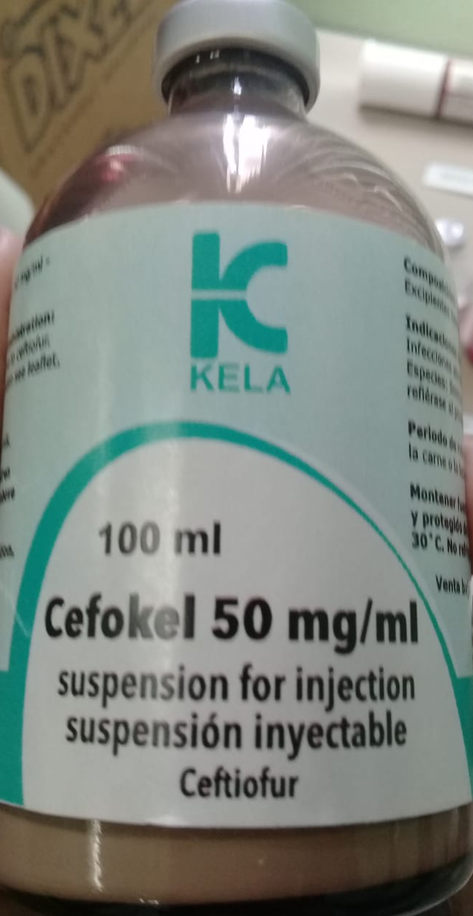 | Cattle, Swine | Infections associated with bacteria sensitive to ceftiofur. | Pigs: 3mg/kg, IM or 1 ml/16kg at each injection.  Cattle:  Respiratory disease: 1mg /kg, SC.  Footrot: 1mg/kg SC injection.  Acute post-partum metritis within 10 days of calving: 1mg/kg for 5 consecutive days SC | Cephalosporin overdoses are unlikely to cause significant  problems other than GI distress, but other effects are possible | Hypersensitive patients to ceftiofur and other β-lactam antibiotics.  Do not inject intravenously.  If resistance to Cephalosporins or beta-lactam antibiotics has occurred. | Ceftiofur is a third generation of cephalosporin, which is active against many Gram-positive and Gram-negative bacteria, including β–lactamase producing strains (except strains producing some type of extended spectrum b-lactamases).  Ceftiofur inhibits the bacterial cell wall synthesis, thereby exerting bactericidal properties.  b-lactams act by interfering with synthesis of the bacterial cell wall. Cell wall synthesis is dependent on enzymes that are called penicillin-binding proteins (PBP's). Bacteria develop resistance to cephalosporins by four basic mechanisms:  1) altering or acquiring penicillin binding proteins insensitive to an otherwise effective b-lactam;  2) altering the permeability of the cell to b-lactams;  3) producing b-lactamases that cleave the b-lactam ring of the molecule, or  4) active efflux.  Some b-lactamases, documented in Gram-negative enteric organisms, may confer elevated MICs to varying degrees to third and fourth generation cephalosporins, as well as penicillins, ampicillins, b-lactam inhibitor combinations, and first and second generation cephalosporins. | Cephalosporins can cause pain at the injection site when administered intramuscularly. Sterile abscesses or other severe local tissue reactions are also possible but are much less common.  Thrombophlebitis is also possible after IV administration of these drugs.  While it has been demonstrated that the cephalosporins (particularly cephalothin) have the potential for causing nephrotoxicity, at clinically used doses in patients with normal renal function, risks for this adverse effect occurring appear minimal.  High doses or very prolonged use has been associated with neurotoxicity, neutropenia,  agranulocytosis, thrombocytopenia, hepatitis, positive Coomb’s test, interstitial nephritis, and tubular necrosis. Except for tubular necrosis and neurotoxicity, these effects have an immunologic component

* No withdrawal time is required for meat or milk

