Drug | Species | Indications | Therapeutic Dose | Lethal Dose/ Toxicity | Contraindications | Pharmacology | Adverse Effects
Amoxxycillin  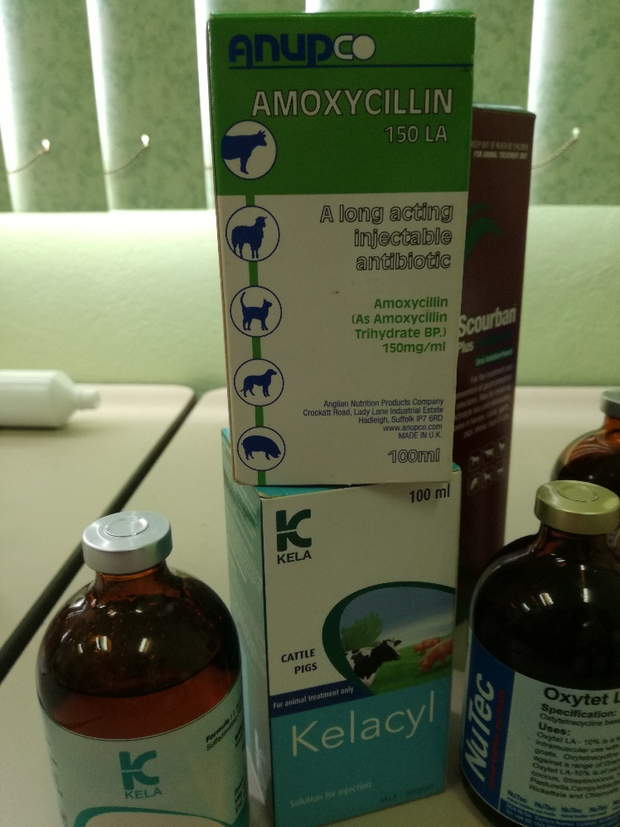 | Cattle, Horses | First drug of choice for suspected infections that have no sensitivity & culture test done | Cattle: 6-10mg/kg  Calves: 7mg/kg PO  Horses: 20-30mg/ kg PO  Foals: 15-30mg/ kg IV/IM | Acute oral penicillin overdoses are unlikely to cause significant  problems other than GI distress although high doses or very prolonged use has been associated with neurotoxicity.  Although the penicillins are not considered to be hepatotoxic, elevated liver enzymes have been reported. | Penicillins are contraindicated in  patients who have a history of hypersensitivity to them. Because there may be cross-reactivity, use penicillins cautiously in patients who are documented hypersensitive to other beta-lactam  antibiotics (e.g., cephalosporins, cefamycins, carbapenems).  Do not administer systemic antibiotics orally in patients with septicemia, shock, or other grave illnesses as absorption of the medication from the GI tract may be significantly delayed or diminished. Parenteral (preferably IV) routes should be used for these cases.  Penicillins have been shown to cross the placenta and safe use of them during pregnancy has not been firmly established, but neither have there been any documented teratogenic problems  associated with these drugs. However, use only when the potential benefits outweigh the risks. | Although there may be some slight differences in activity against certain organisms, amoxicillin generally shares the same spectrum of activity and uses as ampicillin. Because it is better absorbed orally (in non-ruminants), higher serum levels may be attained than with ampicillin.  Penicillins are usually bactericidal against susceptible bacteria and act by inhibiting mucopeptide synthesis in the cell wall resulting in a defective barrier and an osmotically unstable  spheroplast. The exact mechanism for this effect has not been definitively determined, but betalactam  antibiotics have been shown to bind to several enzymes (carboxypeptidases,  transpeptidases, endopeptidases) within the bacterial cytoplasmic membrane that are involved with cell wall synthesis. The different affinities that various beta-lactam antibiotics have for these enzymes (also known as penicillin-binding proteins; PBPs) help explain the differences in spectrums of activity the drugs have that are not explained by the influence of beta-lactamases. | Adverse effects with the penicillins are usually not serious and have a relatively low frequency of occurrence.  Hypersensitivity reactions unrelated to dose can occur with these agents and can be manifested  as rashes, fever, eosinophilia, neutropenia, agranulocytosis, thrombocytopenia, leukopenia,  anemias, lymphadenopathy, or full blown naphylaxis.  When given orally, penicillins may cause GI effects (anorexia, vomiting, diarrhea). Because the  penicillins may also alter gut flora, antibiotic-associated diarrhea can occur, as well as selecting  out resistant bacteria maintaining residence in the colon of the animal (superinfections).

