Drug | Species | Indications | Therapeutic Dose | Contraindications | Adverse Effects
Dexakel® 0.2 Dexamethasone  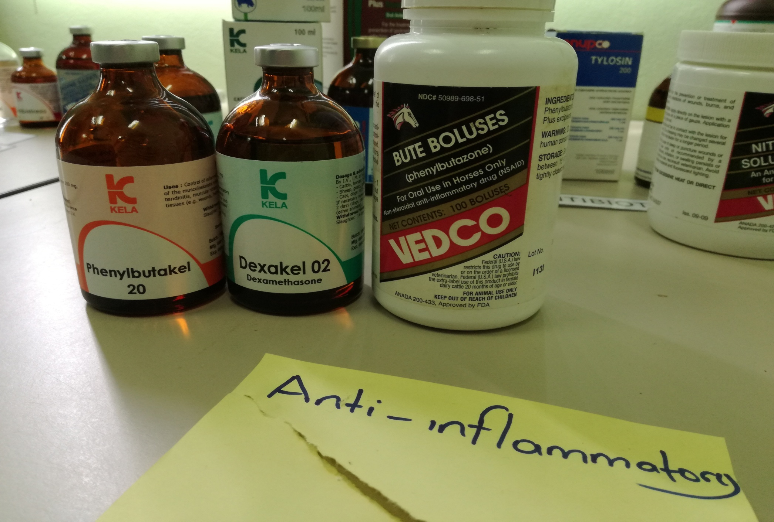 | Cattle, Horses, sheep, goats, calves | Metabolic disorders, non- infectious inflammatory processes, especially acute musculoskeletal inflammations, allergic conditions, stress- and shock conditions. As an aid in acute infectious disease.  Induction of parturition in ruminants during the last stage of pregnancy. | Cattle, horses: 5-10 mL/400kg body weight  Sheep, goats, calves: 1-2 mL/ 50kg body weight  If necessary, repeat with intervals of 3-4 days. | Animals suffering from diabetes mellitus, osteoporosis, heart disorders caused by blood vessel congestion, kidney failure, tuberculosis, hypercorticism, acute pancreatitis, viremia and at the same time with vaccination.  Should not be used in pregnancy, epilepsy, severe parasitosis, viral infections, cardiac, renal and gastric disorders, corneal ulcer, glaucoma, and vaccination (due to immunosuppressive effects) as well as before major surgery because it slows down the healing of the wound. | Adverse effects are generally associated with long-term  administration of these drugs, especially if given at high dosages or not on an alternate day regimen. Effects generally are manifested as symptoms of hyperadrenocorticism. When administered too young, growing animals, glucocorticoids can retard growth.

