Drug | Species | Indications | Therapeutic Dose | Contraindications | Pharmacology | Toxicity
Phenylbutakel® 20  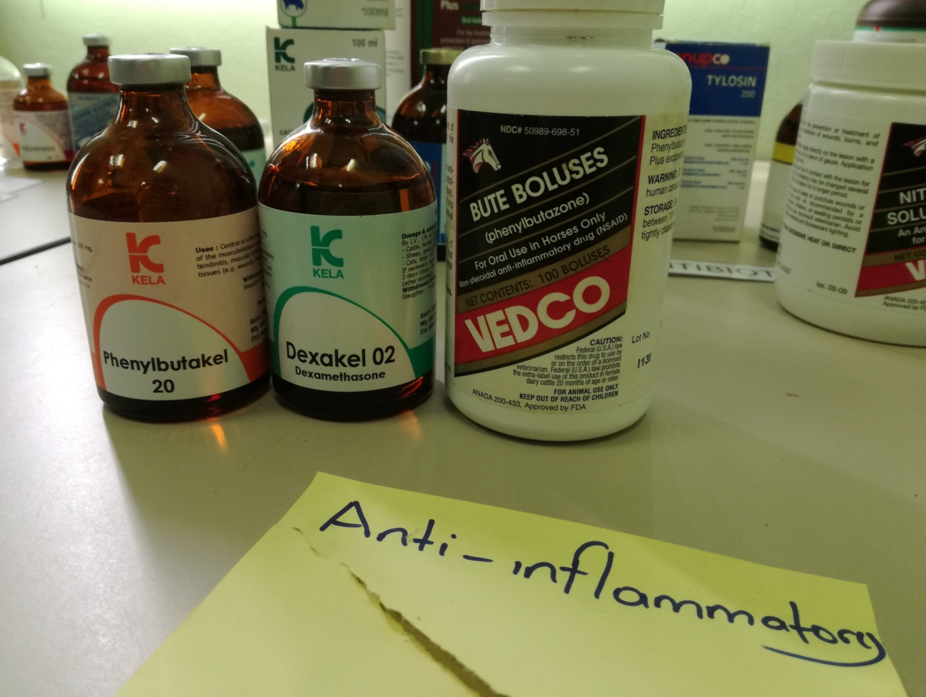 | Cattle, Horses, Pigs | A nonsteroidal anti-inflammatory drug with excellent anti-inflammatory, analgesic and antipyretic properties.  For control of inflammation, subsequent tissue damage and associated pain.  Phenylbutazone is especially of value for relief of acute inflammatory conditions associated with the musculoskeletal system and lameness.  Particular uses: Laminitis in cattle and horses, lymphangitis in horses, soft tissue reactions and pain associated with e.g. wounds, fractures, bruises, etc | Deep intramuscular or slow intravenous routes of administration.  Cattle: initial dose:  1 mL/ 25kg, maintenance dose: 1mL/ 50-70 kg/ day or every 2 days I.V. or I.M. (max. 5 days)  Calves: 1 ml/50 kg with 2-days intervals  Horses: 1mL/50 kg/day I.V. (max. 5 days)  Pigs: 1 Ml/50 kg/ day I.M. | Do not administer injectable preparation IM or SC, as it is very irritating (swelling, to necrosis  and sloughing). Intracarotid injections may cause CNS stimulation and seizures., | An analgesic, anti-inflammatory, antipyretic, and mild uricosuric properties. The proposed mechanism of action is by the inhibition of cyclooxygenase,  thereby reducing prostaglandin synthesis. Other pharmacologic actions may  induce include reduced renal blood flow and decreased glomerular filtration rate, decreased  platelet aggregation, and gastric mucosal damage. | Toxic effects that have been reported in horses include  oral and GI erosions and ulcers, hypoalbuminemia, diarrhea, anorexia, and renal effects  (azotemia, renal papillary necrosis).

*

