Drug | Species | Indications | Therapeutic Dose | Contraindications | Pharmacology | Adverse Effects
Babex Injection/ Imidofin®  Injectable 12%  (Imidocarb Dipropionate)  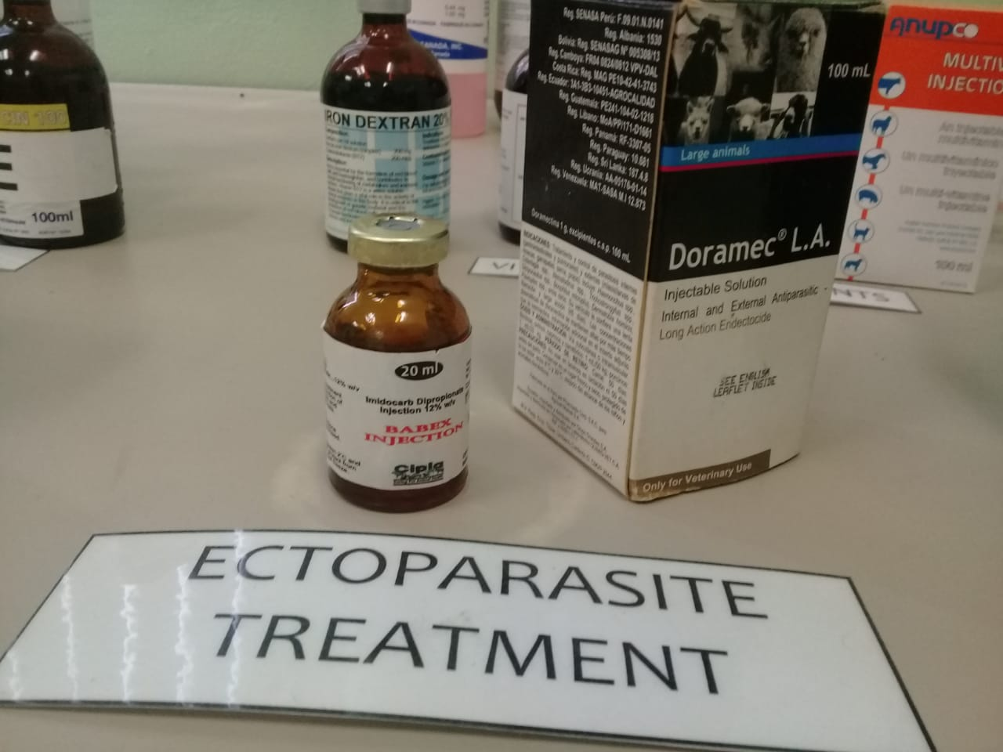 | Cattle, Horses | Treats and prevents equine piroplasmosis: Babesia caballi and B. equi, Anaplasmosis and Babesiosis in cattle. Only Imidofin is used in cattle for this purpose. | Cattle and Calves:  Babesiosis:  Treatment - 1ml/100kg SC. Prevention – 2.5ml/100kg SC  Anaplasmosis:  Treatment- 2.5ml/100kg SC  Eliminate carrier state: 4ml/100kg SC  Horses:  B. equi Tx: 3.5ml/ 100kg, 4 times at 72-hour intervals  B. caballi Tx: 2ml/ 100kg IM once daily for 2 consecutive days | Animals exposed to pesticides or cholinesterase-inhibiting drugs. Animals with impaired renal or liver function. IV administration.  Do not administer to weak animals. | Imidocarb is thought to act by combining with nucleic acids of DNA in  susceptible organisms, causing the DNA to unwind and denature. This damage to DNA is  believed to inhibit cellular repair and replication. | A painful, inflammatory reaction may be seen at the injection site, even during a few days. Increased salivation, nasal discharge and vomiting can be seen shortly after injection. Some dog and sheep breeds can show transient side effects.

*Withdrawal period: meat : 90 days, milk : 7 days

