Drugs Information
Weight= 500kg
Ketamine
Dose= 0.25mg/kg
Concentration= 100 mg/ml
Dose to be administered= (500 * 0.25)/ 100 = 1.25ml

Xylazine
Dose= 0.05mg/kg
Concentration= 20mg/ml
Dose to be administered= (500*0.05)/20
= 1.25 ml

Lidocaine
Dose= 10 mg/kg
Concentration= 20mg/ml
Toxic Lidocaine= 500 *10/20
=250ml therefore max dose is 125ml.
In Teat surgery Lidocaine is indicated in the ring block:
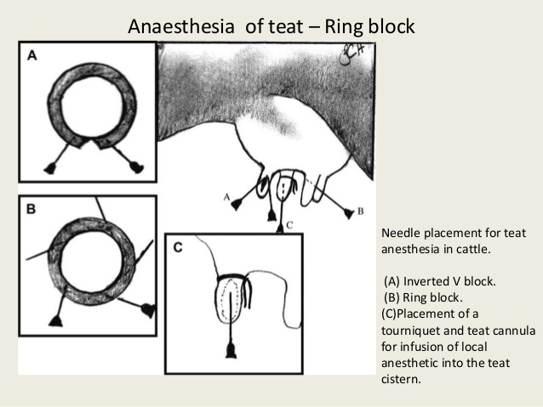

Atropine
Dose=0.04 mg/kg
Concentration= 0.54 mg/ml
Dose to be administered= 37 ml

Epinephrine
Dose=0.02 mg/kg
Concentration= 1mg/ml
Dose to be administered= 10ml

Tolazoline
Dose= 0.1 mg/kg or 0.2mg/kg
Concentration=100 mg/ml
Dose to be administered= (500*0.1)/100 or (500*0.2)/100
=0.5ml or 1ml
Flunixine
Dose= 1.1mg/kg
Concentration= 50 mg/ml
Dose to be administered= (500* 1.1)/50
=11ml
Pen Strep
Dose= 10,000
Concentration=200,000
Dose to be administered= (500*10,000)/ 200,000
=25ml

Pen Strep
Dose=10, 000 mg/kg
Concentration= 200,000 mg/ml
Dose to be administered= (500*10,000)/ 200,000
= 25 ml

