EQUIPMENT /TOOLS FOR HOOF TRIMMING

Electric Hoof Grinder  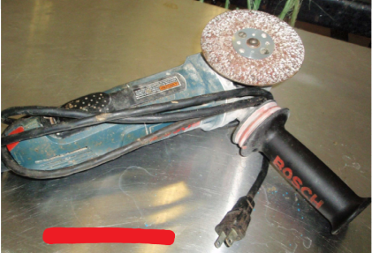 | Advantage: It is easier to and less time consuming than the manual hoof knife and hoof rasp.  Disadvantage: More expensive and needs experience and knowledge to properly operate the machine.  https://www.youtube.com/watch?v=OR6B9i18xMY&feature=youtu.be
Rasp  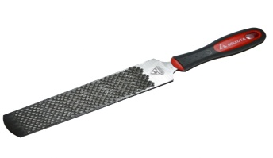  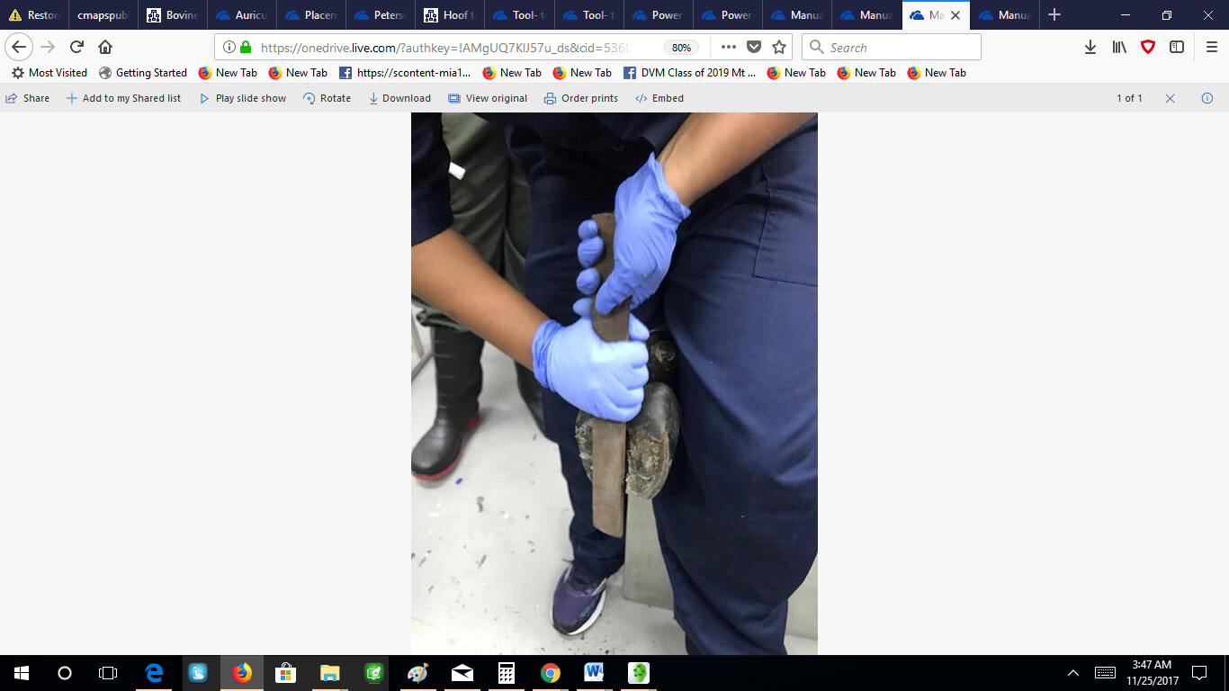 | Advantage: Use to smoothen and fine tune certain areas of the hoof.  Disadvantage: More time consuming and need more effort and strength.
Hoof Nipper  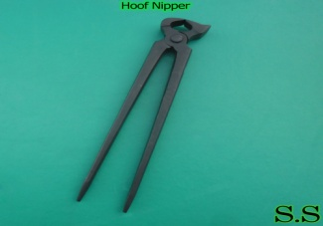 | Advantage: Used to reduce and align the apex of the toes or hoof cost affordable.  Disadvantage: Can be difficult to use if not properly sharpened, and it needs more effort and strength than the electrical cutter.
Electric Hoof Cutter  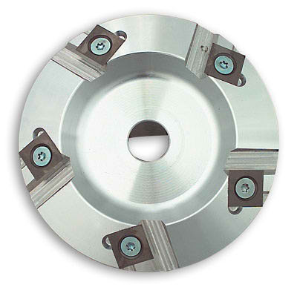 | Advantage: Much easier to use that than the hoof nippers, less strength and manual work Is needed.  Disadvantage: More expensive and needs experience and knowledge to properly operate the machine. It can cause a lot of damage to the hoof if not properly handled.
Electrical Hoof Knife  (Merlin)  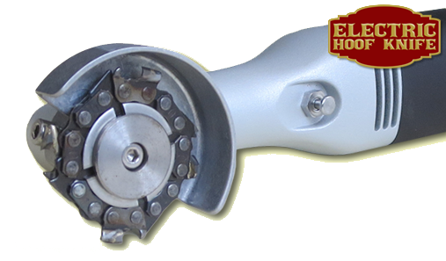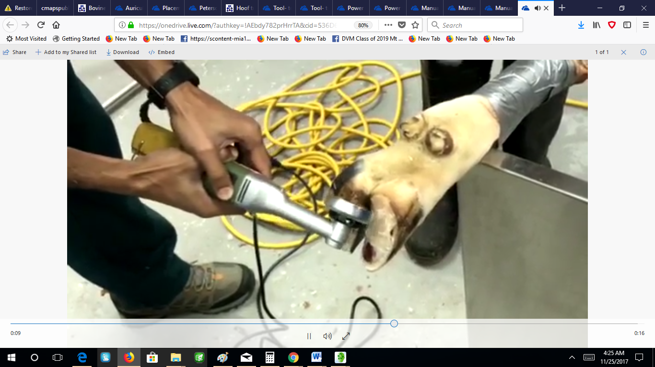 | Advantage: Used to make more precise cuts than the grinder and cutter  Easier to manipulate. Can be use to fine tune and smoothen the curvature on the axial hoof wall and less time consuming than the rasp.  Disadvantage: More expensive, need prior experience and knowledge to properly operate.  https://www.youtube.com/watch?v=Dgz7xCx0o_A
Hoof Clipper/ cutting shears  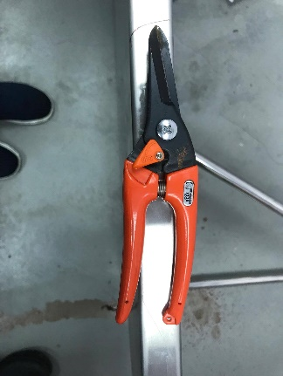 | Advantage: Used to trim the outgrowth of the hoof wall from the hoof.
Ruler  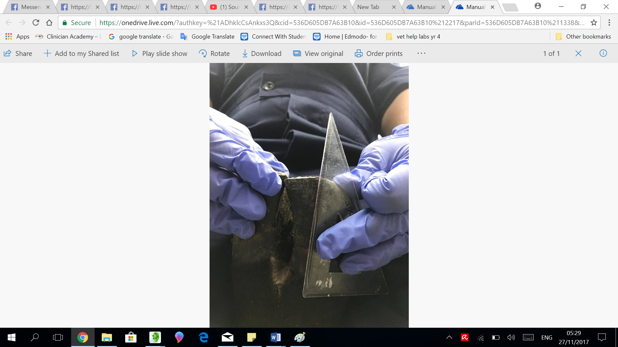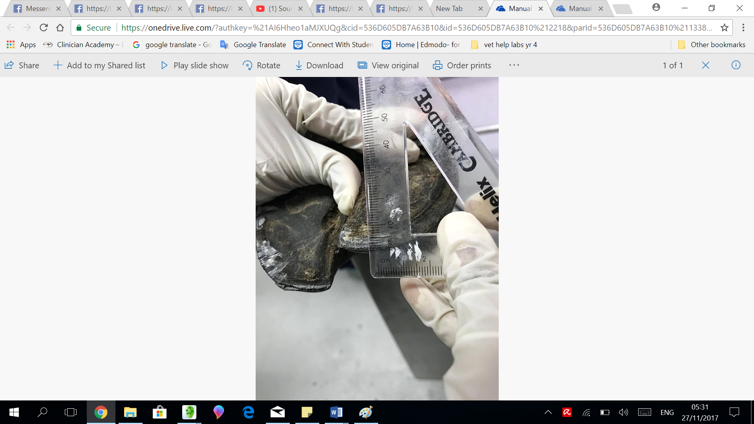 | Advantage : Used to measure the toe height and dorsal hoof wall to decipher how much of the hoof to remove.
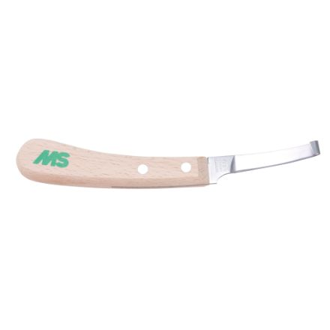  Hoof Knife  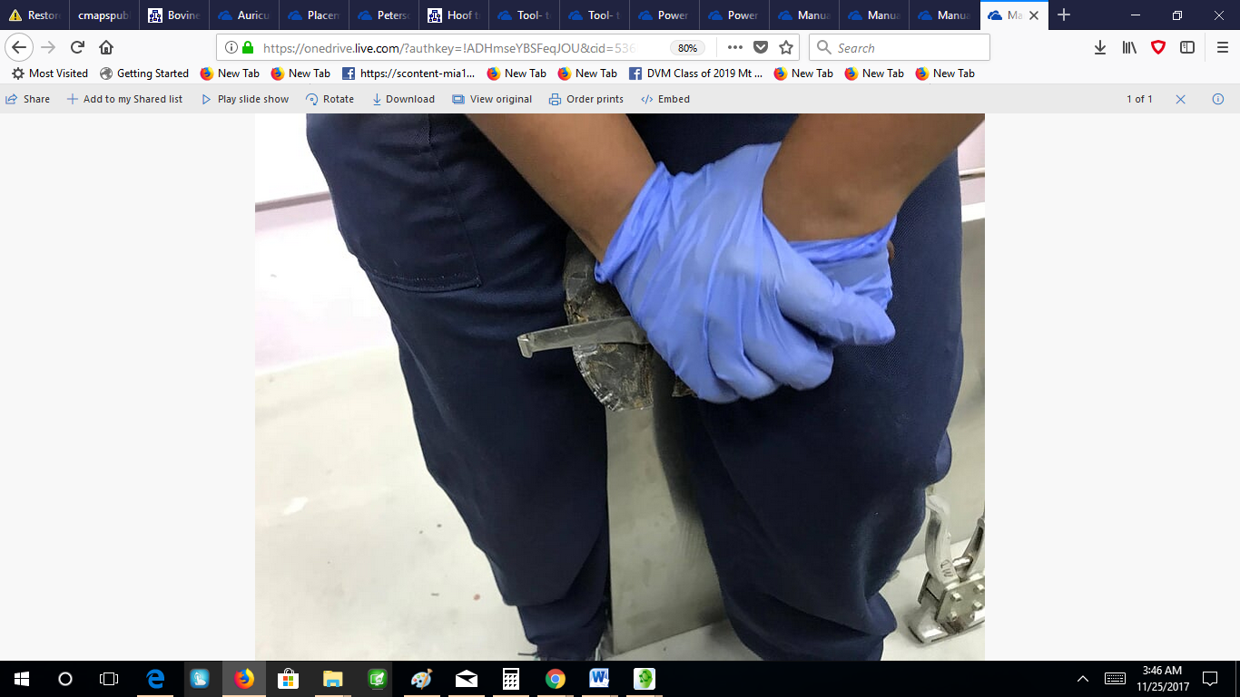 | Advantage: Used to debride the hoof and remove the sole, trim the shedding frog and sculpt the bars. To trim away dried out sole.  Disadvantage: More time consuming than the electric hand cutter. May make hand sore from usage.

REASONS FOR DOING HOOF TRIMMING

The Main reason is to prevent lameness associated with hoof problems, but in the case where problems do arise with the hoof, they can be corrected using specific hoof trimming techniques. This will in turn prevent a reduction in production due to lameness caused by hoof problems. The problems that tend to occur mostly include: Overgrown Horns, Hoof wall ulcers and Damage to the hoof.

