**Anatomy**

The bovine teat is composed of five primary layers to the lining of teat: the inner most layers of mucosa, submucosa, highly vascularised connective tissue, muscularis and the skin. Innervation of the udder is by fibres of the genitofemoral nerve. The cranial quarters are innervated by the ilioinguinal and iliohypogastric nerves. The caudal quarters are innervated by the mammary branch of the pudendal nerve and the distal branch of the perineal nerve.

The most important support of the udder is the median suspensory ligament (MSL). It divides the udder into right and left halves. The median suspensory ligament is composed of elastic tissue that stretches to allow the udder to expand as it fills with milk.

The lateral suspensory ligament (LSL) is chiefly fibrous and non-elastic. It extends along both sides of the udder and at the intervals send sheets of tissue into the gland to provide support to the inside contents of the udder.

**Pictures below depicting the anatomy of the bovine mammary gland.**

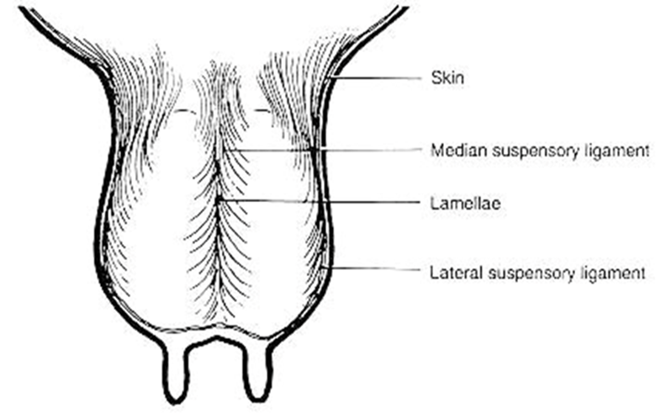

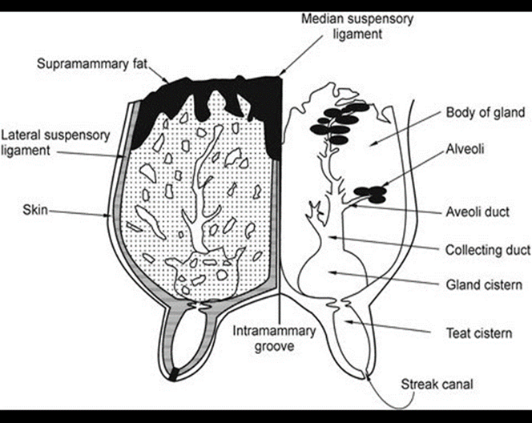

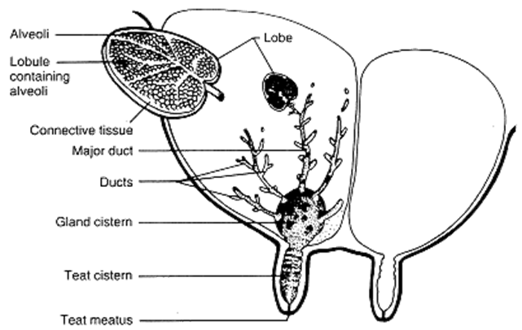

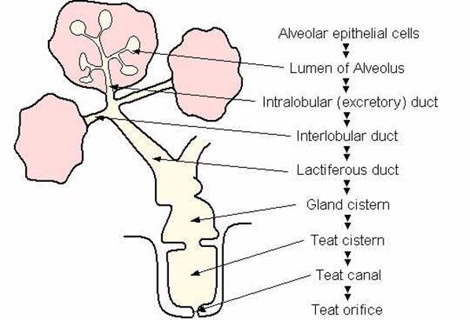

**Picture below depicting the innervation of the Bovine mammary gland.**

