Instruments used with Teats
Udder-Infusion Cannula
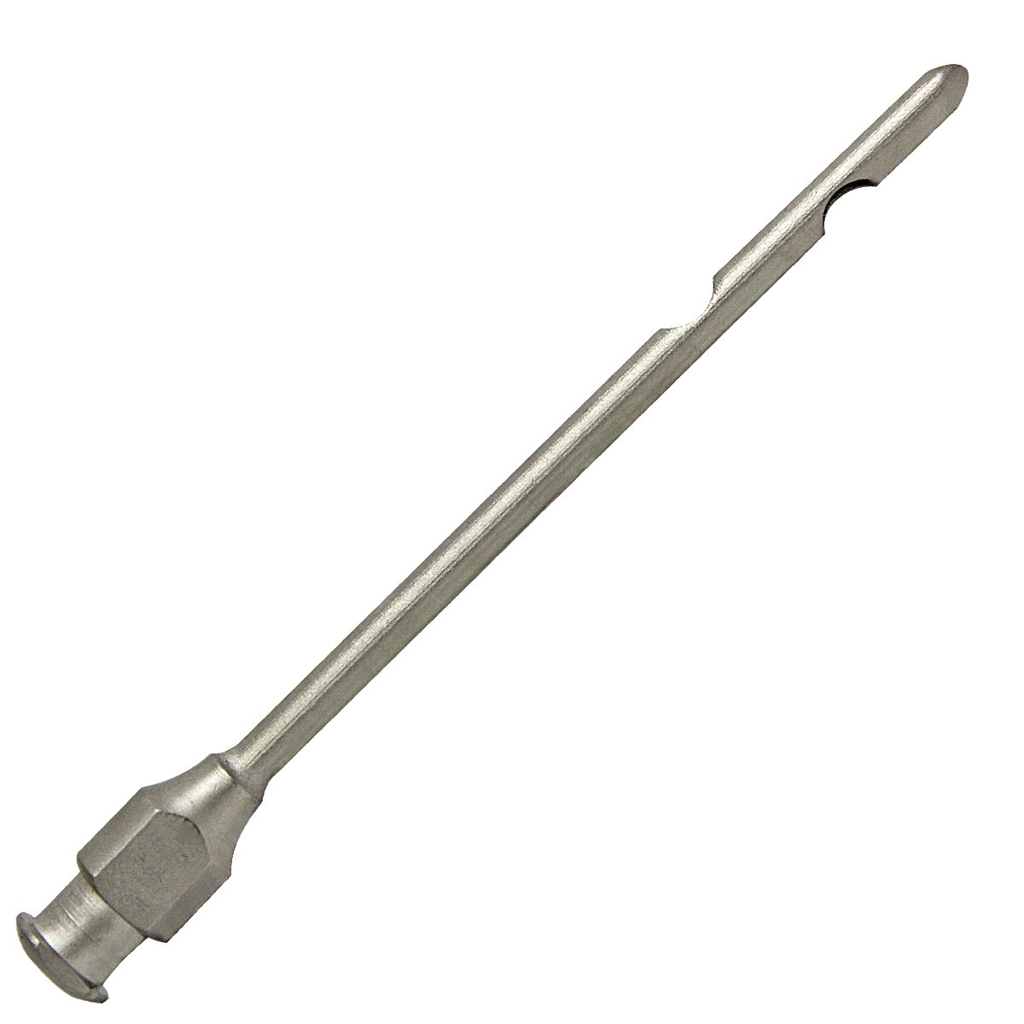
Used to administer drugs into the teat canal. Also, it can be used to help drain a mastitic quarter, to keep a teat canal or sphincter open during or after surgery, to flush an abscess or to perform a peritoneal tap.
Self-Retaining Cannula
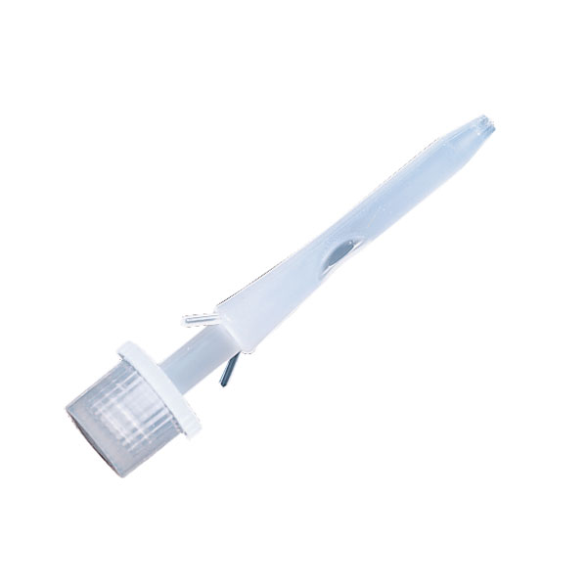
Used to keep injured teat open.
Teat Dilator
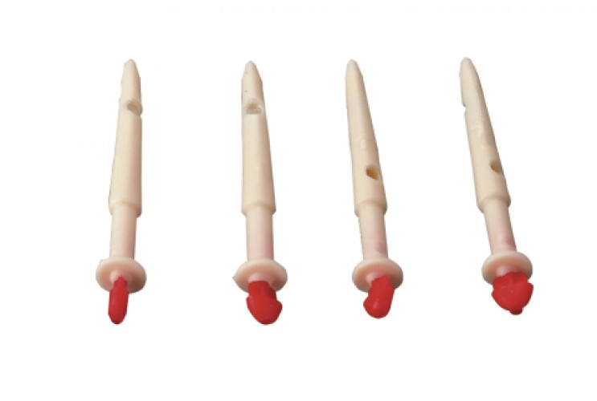
Used to open the teat canal
Tumor Remover
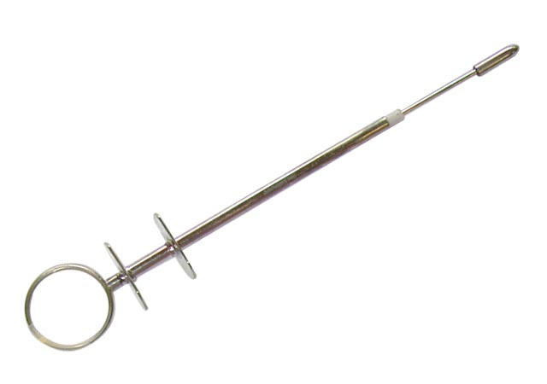
It has a sharp blade on the inside that gets exposed when the plunger is depressed. Used to remove masses in the teat canal.
Teat Slitter
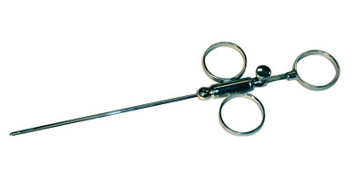
It has blades that come out from its sides for cutting from inside the canal to outside. Used to make 2 cuts that open up small teat sphincters.
Doyen Clamp
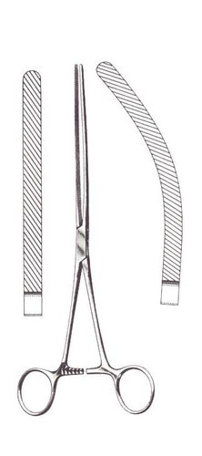
Used to prevent milk coming out of the mammary gland during surgery and material going into the gland.

