# Peterson Nerve Block

|  |  |
| --- | --- |
| Indications | Used to desensitize abducens, trigeminal, optic, trochlear and oculomotor nerves |
| Drugs | 2% lidocaine, volume administered 15-20ml |
| Procedure | 1. A 18 gauge, 3.5 inch long spinal need was inserted caudal to the junction of the supraprbital process and zygomatic arch 2. The needle is directed horizontally and slightly dorsal until coronoid process is encountered 3. The need I walked off the rostral aspect of the coronoid process and advanced ventromedially along the caudal aspect of the orbit until need encounters bone around the foramen obitorotundum 4. The needle is pulled back a few millimeters, aspirated and 10-15ml 2% lidocaine is administered and an additional 5ml while needle is withdrawn |
| Complications | 1. Can enter the internal maxillary artery and cause hemorrhaging 2. If you apply too much force when advancing the needle you can administer the drug in the meninges 3. Apnoea 4. Accidental penetration of the globe |

**Land mark:**

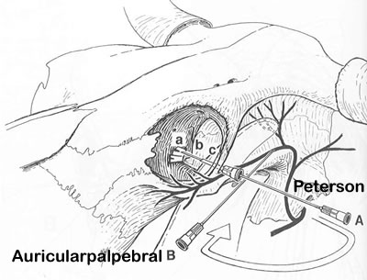

# Auriculopalpebral Nerve Block

|  |  |
| --- | --- |
| Indications | Used to prevent upper eyelid movement during eye examination, surgery or before performing a Peterson or retrobulbar block |
| Drugs | 5ml 2% lidocaine |
| Procedure | 1. Palpate the auriculopalpebral never across the zygomatic arch 5-6cm behind supraorbital process 2. 5ml of 2% lidocaine is injected subcutaneously using an 18 gauge 1 inch needle on the dorsal aspect of the zygomatic arch at this location. |
| Complications | 1. Does not provide analgesia to the eye 2. Hematoma 3. Infection of the injection site 4. Hemorrhaging |

**Landmark:**

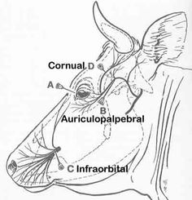

# Retrobulbar or 4 Point Nerve Block

|  |  |
| --- | --- |
| Indications | Used to desensitize optic, oculomotor, trochlear, trigeminal and abducens nerves around the globe |
| Drugs | 40ml of 2% lidocaine |
| Procedure | 1. Using a 18 gauge 3.5 inch spinal needle, it is inserted at the medial and lateral cantus and upper or lower eyelids and is directed behind the globe 2. The needle is then aspirated and 10ml if 2% lidocaine is administered at each site |
| Complications | 1. Hemorrhage 2. Penetration of the globe 3. Damage to optic nerve 4. Intrameningial injection |

**Landmark:**

