**SURGICAL PROCEDURE FOR ENUCLEATION / EXENTERATION**

Following surgical preparation, the patient’s affected eye surrounding was draped with a sterile drape and kept in place with the use of a towel clamp.

The patient’s eyelids were closed together in a simple continuous suture pattern and the ends were left long. This was done to use as traction on the eye throughout the surgery and provide a seal to minimize contamination of the surgical field.

A transpalpebral (elliptical) incision was made around the orbit, leaving as much undamaged tissue as possible. The incision was 1cm from the margin of the eyelid. The ventral incision and subsequent dissection were done through the subcutaneous tissue, orbicularis oculi and around the conjunctival fornices. Sharp or blunt dissection was used for 360° around the entire orbit continuing down to the caudal aspect of the orbit, but avoiding entrance through the palpebral conjunctiva (ensure both the lateral and medial canthus are incorporated and avoid the ogularis oculi vein at the medial canthus).

When the optic stalk and blood supply was reached, a curved haemostat (forcep) was used to grasp the stalk. The stalk was then severed distally. All muscles, adipose tissue, the lacrimal gland, and fascia were removed, along with the eyelids and eyeball.

The orbit was packed with sterile gauze for five (5) minutes to stem any haemorrhage which might occur and removed before completion of closure with suture.

Closure was done with a subcutaneous layer of simple continuous suture pattern using a 2-0 absorbable suture and interrupted horizontal mattress suture pattern was placed in the skin using 0 synthetic nonabsorbable suture material.

Sutures are to be removed 2–3 weeks postoperatively.

The surgical site was wiped gently with some hydrogen peroxide on a gauze. The surgical area was sprayed with oxytet and a bandage was applied over the surgery site to minimise damage to the area.

**NOTE: Transpalpebral enucleation is the removal of the globe, short piece of the optic nerve, lid margin, conjunctiva, the 3rd eyelid and the gland of the 3rd eyelid. Exenteration involves transpalpebral enucleation plus the removal of all the orbital contents.**



**Picture showing the surgical technique**

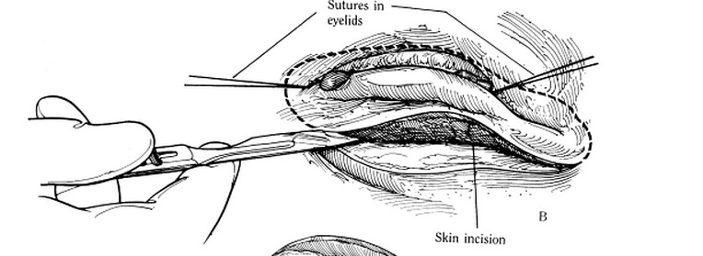

**Picture showing a transpalpebral incision around the orbit**

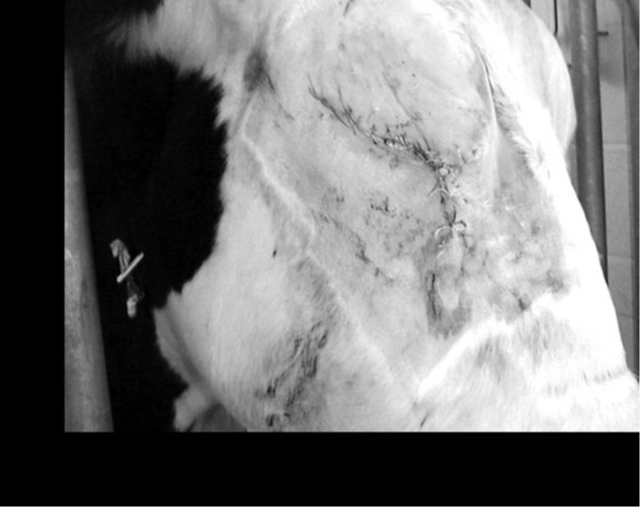

**Closure of the surgical site following enucleation in a cow.**

**VIDEOS:**

https://www.youtube.com/watch?v=UxSEqTnnUpA

https://www.youtube.com/watch?v=ulKIpRTa3K0

https://www.youtube.com/watch?v=KlW7lJJEJf0

https://www.youtube.com/watch?v=dUAItCylgrE

https://www.youtube.com/watch?v=ad3F0f3lGsk