EVISCERATION IN CATTLE

Principle:

The removal of the contents of the eye leaving only the scleral shell.

Method*:*

1. The operation can be performed under local anaesthetic using a retrobulbar

block. If the tissues are inflamed more anaesthetic than usual will be required.

It is advisable to give some additional systemic analgesia and sedation as well

*e.g. Pethidine* 100 mg IM. If facilities for general anaesthesia are available a

general anaesthetic is probably better in cases of endophthalmitis.

1. A speculum is inserted to part the lids.
2. Using a scalpel, a small full-thickness scleral stab incision is made, posterior to the limbus (fig. 10.1) cornea is then removed with Westcott scissors via a circumferential incision (fig. 10.2).
3. The contents of the eye are removed with a sharp curette or spoon (E.g. Freer periosteal elevator) (fig. 10.3).

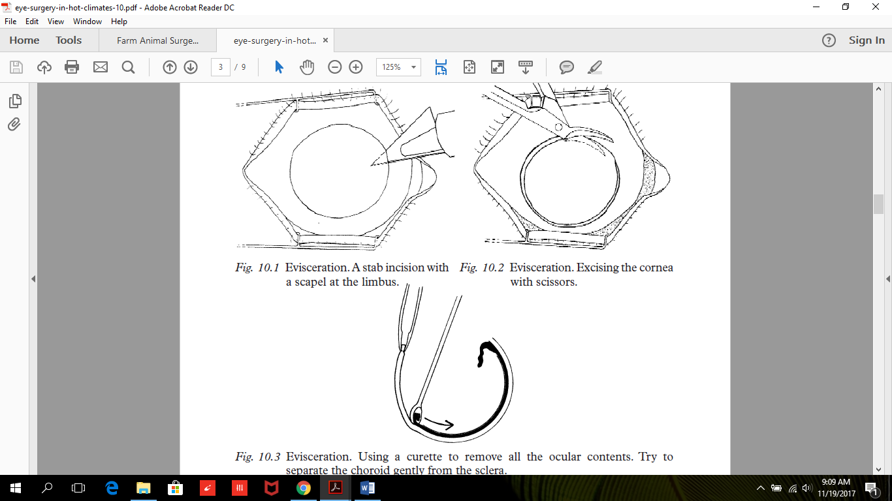

A fair amount of bleeding is common can be controlled with gentle bipolar cautery. It is extremely important to make sure that all the black choroid is removed leaving bare white sclera. If any choroidal tissue is left, there is a risk of sympathetic ophthalmitis occurring later. Cleaning the scleral cavity with a swab soaked in 5% phenol helps to lessen postoperative pain.

1. The sclera can be left open to drain. This is advisable in endophthalmitis, but otherwise excessive sclera is trimmed, and the sclera is closed with multiple interrupted 5-0 Mersiline sutures.
2. Tenon's capsule is closed first with multiple interrupted 5-0 Vicryl sutures. The conjunctiva closed over it as another layer with a running suture.
3. Antibiotic ointment is applied under a double pad and a firm bandage.

NB: For Implant

Scleral windows oriented in an anterior to posterior direction are cut in the sclera in the four quadrants between the recti muscles using scissors. The sclera can also be opened around the optic nerve. These scleral windows allow for vascular ingrowth if a porous implant is placed. To create the Anterior Scleral Window, scissors are used to make two cuts at the anterior opening of the sclera in an inferior-medial and superior-lateral direction to facilitate implant placement into the sclera.

Post-operative care:

* The socket is usually left for 2 days before inspection. There is often considerable swelling

of the conjunctiva which may protrude between the eyelids. This will settle after some days.

* Antibiotic ointment is applied regularly, and the patient can be discharged if feeling well.
* Once the swelling and inflammation has settled an artificial eye can be inserted.