Days Post- op | SOAP of sheep #1
7th November, 2017 | Subjective: BAR  Objective  T- 38.5 °C  P-105 beats per minute  R-32 breaths per minute  CRT- <2 secs  Pink mucous membranes, no dehydration, normal strong heartbeat, eyes, ears and nares all observed normal. Normal faeces, no urine seen.  Assessment  Wound site was slightly swollen, no abnormal discharges (NAD), wound edges well appositioned, and no sign of fly strike. Apparent pain on touching wound.  Plan  1mL tetanus antitoxin  The wound was sprayed with tetravet and Larvicide was sprayed around the wound.  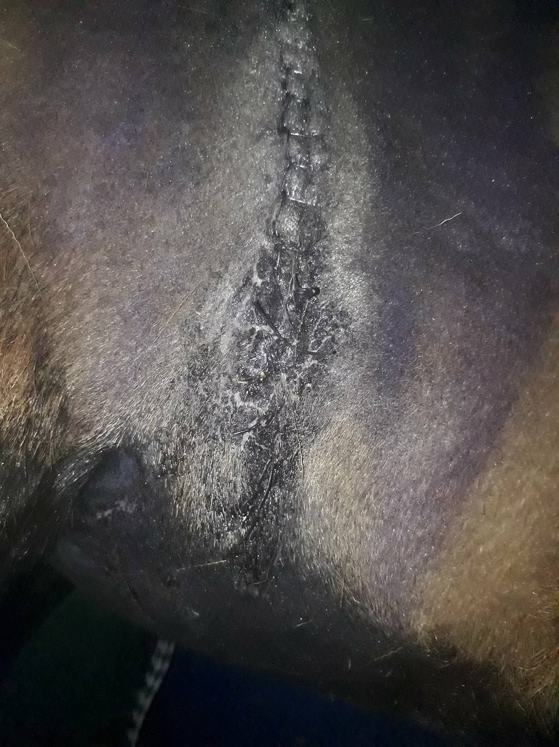
8th November 2017 | Subjective: BAR  Objective:  T: 38.9 °C  P: 108 beats per minute  R: 40 breaths per minute  CRT- <2 secs  Pink mucous membranes, no dehydration, normal strong heartbeat, eyes, ears and nares all observed normal. Normal faeces and urine.  Assessment:  Wound site had a small swelling about 2 inches wide noted on caudoventral end of incision. No sign of fly strike. On palpation, no signs of pain, heat, discharges were detected.  Walking and standing.  Plan:  The wound was sprayed with tetravet and Larvicide was sprayed around the wound.  1mL of Flunixin was administered IV  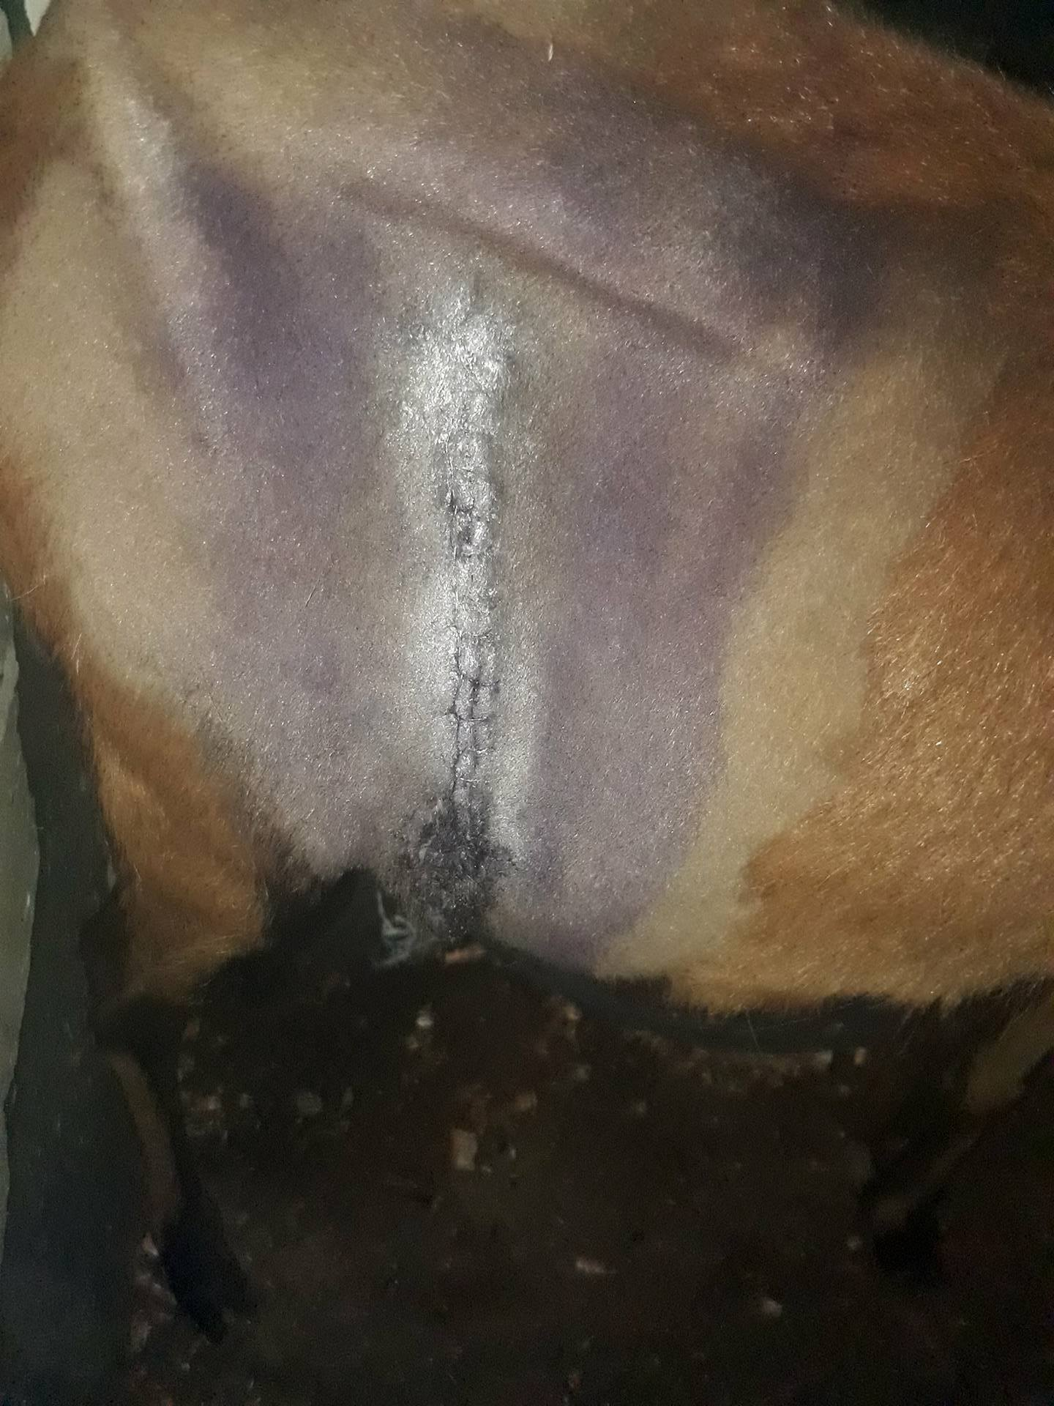
9th November 2017 | Subjective: BAR  Objective:  T: 38.5 °C  P: 48 beats per minute  R: 40 breaths per minute  CRT- <2 secs  Pink mucous membranes, no dehydration, normal strong heartbeat, eyes, ears and nares all observed normal. Normal faeces and urine.  Walking and standing.  Assessment:  No sign of fly strike. On palpation, no signs of pain, swelling, heat, discharges were detected.  Plan:  The wound was sprayed with tetravet and Larvicide was sprayed around the wound.  1mL of Flunixin was administered IV  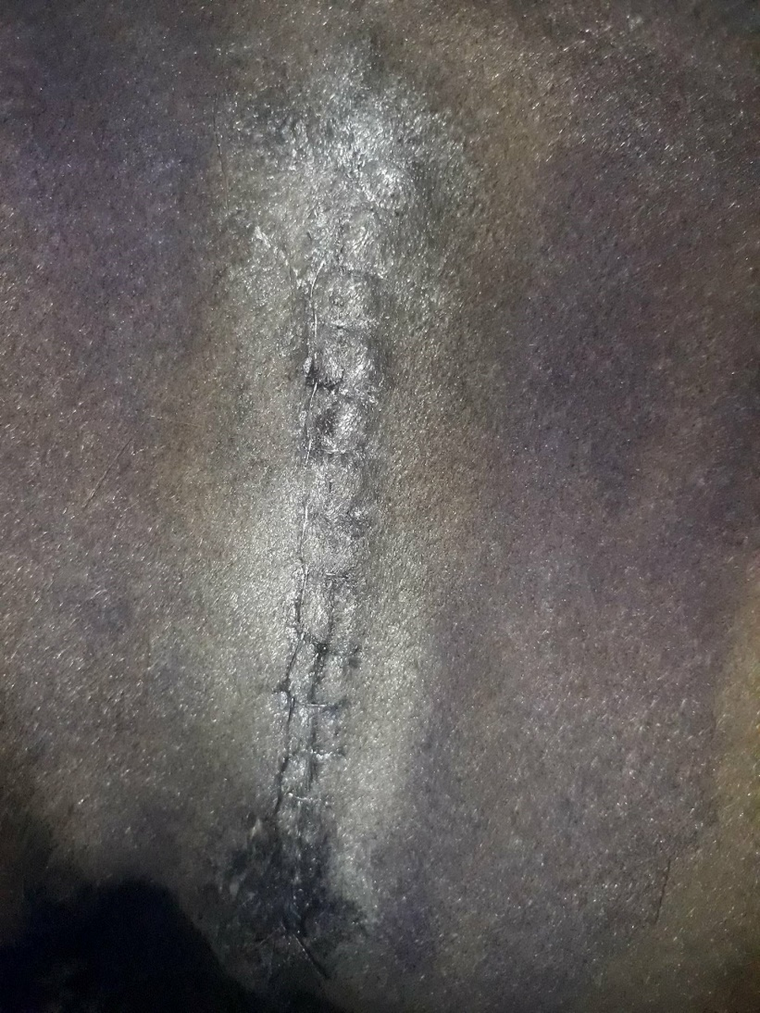
10th November 2017 | Subjective: BAR  Objective:  T: 100.2 °F  P: 80 beats per minute  R: 24 breaths per minute  CRT- <2 secs  Pink mucous membranes, no dehydration, normal strong heartbeat, eyes, ears and nares all observed normal. Normal faeces and urine. Rumen rate: 1 in 2 mins  Walking and standing.  Assessment:  No sign of fly strike. On palpation, no signs of pain, swelling, heat, discharges were detected.  Plan:  The wound was sprayed with tetravet and Larvicide was sprayed around the wound.  4.72 mL Penstreptomycin was administered.
11th November 2017 | Subjective: BAR  Objective:  T: 39 °C  P: 96 beats per minute  R: 60 breaths per minute  CRT- <2 secs  Pink mucous membranes, no dehydration, normal strong heartbeat, eyes, ears and nares all observed normal. Normal faeces and urine. Rumen rate: 1 in 2 mins  Walking and standing.  Assessment:  No sign of fly strike. On palpation, no signs of pain, swelling, heat, discharges were detected.  Plan:  The wound was sprayed with tetravet and Larvicide was sprayed around the wound.
12th November 2017 | Subjective: BAR  Objective:  T: 102.7 °F  P: 100 beats per minute  R: 40 breaths per minute  CRT- <2 secs  Pink mucous membranes, no dehydration, normal strong heartbeat, eyes, ears and nares all observed normal. Normal faeces and urine. Rumen rate: 2 in 3 mins  Walking and standing.  Assessment:  No sign of fly strike. On palpation, no signs of pain, swelling, heat, discharges were detected.  Plan:  The wound was sprayed with tetravet and Larvicide was sprayed around the wound.

