**Preoperative Considerations**

**Surgical site Preparation**

The area between the last rib and tuber coxae was clipped and cleaned with chlorhexidine followed by iodine and alcohol before surgery.

**Equipment**

* Stethoscope
* Thermometer
* Halter
* Rope
* Gauze
* Iodine
* Alcohol
* Needles

**Anatomical Knowledge**

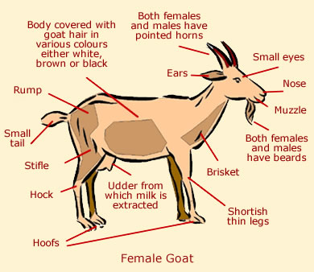

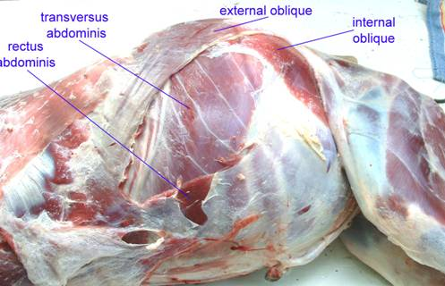

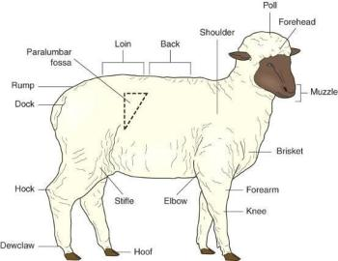

**ASA Grade**

Sheep #1 – Grade 1

**Distance Exam**

Sheep #1 was BAR on distance examination.

The animal's gait was normal.

Coat condition: Good no visible ectoparasites.

The pen was moderately dry and clean and was appropriately stocked.

There was food kept in a basket above ground and water kept in a concrete tub at an appropriate height for sheep.

The animal's gait was normal.

Coat condition: Good no visible ectoparasites.

The pen was moderately dry and clean and was appropriately stocked.

There was food kept in a cut barrel above ground and water kept in a tub at an appropriate height for sheep.

**Possible complications**

* Haemorrhage
* Infection
* Damage to internal organs
* Formation of internal scar tissue (adhesions)
* Bowel blockages or abdominal pain, which may be caused by adhesions.